STEPS Individualized Service Plan Instructions

Page 1
Complete the top half of the form with the relevant information for the member, their guardian/ representative, MCO and Community Service Coordinator.
If you do not have the member’s PPL ID number for the initial Service Plan, please reach out to the member’s MCO or the KDHE STEPS Program Manager.

Service Plan History Section
The start and end dates of a member’s very first STEPS Service Plan should be entered on the Initial Service Plan Start line. The dates on this line should NOT be removed if the history section ever gets too large for the table.
Each time a Service Plan is revised or updated, choose a type from the dropdown. If the Plan is not the annual, please enter the reason why it’s being revised.
The End Date for any subsequent Service Plans should align with the Initial Service Plan dates. For example, if a member changes a service provider at any point during the Plan period, the end date should still match the end date of the current Service Plan.
If a Service Plan includes a Supported Employment reduction that will overlap (or any other changes that will overlap) the Service Plan end date, the end date should still match the end date of the current service plan and the remainder will carry over onto the next Service Plan. The services table on Page 2 will outline the specific dates that services and hours will follow in the case of overlap.
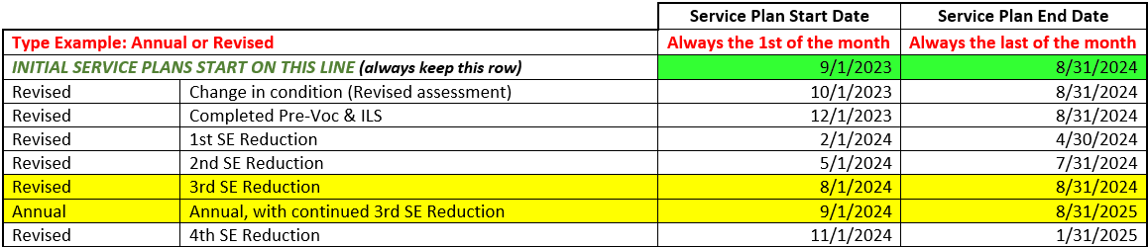
If a member has gone through multiple Plan revisions and the table is full, delete all but the Initial Service Plan row and note that some of the history is being omitted.
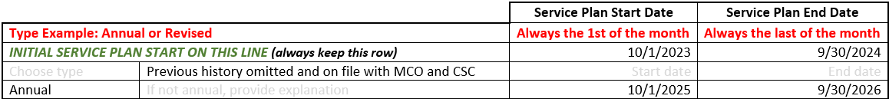

Page 2

Services Table
The Services Table is used to outline the services being authorized for the upcoming/revised/annual Service Plan period only. An exception could be in the cases where the end date of a service is going to overlap into the next Service Plan period (e.g., SE reduction).
Use the check box to the left of the Service Type to indicate which services are included in the upcoming/ revised/annual Service Plan.
Enter the number of hours/units from the STEPS Services Assessment and/or Justification Form in the yellow box under Amount. The number of units for Med Minder Install/Monthly and PERS Install/Monthly always equals 1. Frequency is already determined by the Service Type.
Enter the name of the service provider under Provider Name. Set the Begin and End dates according to the Service Plan period. In the case of SE reductions, enter the Begin and End dates according to the quarterly reduction schedule. Med Minder and PERS installations can be authorized for up to 2 months to allow time for the services to be installed/set up.
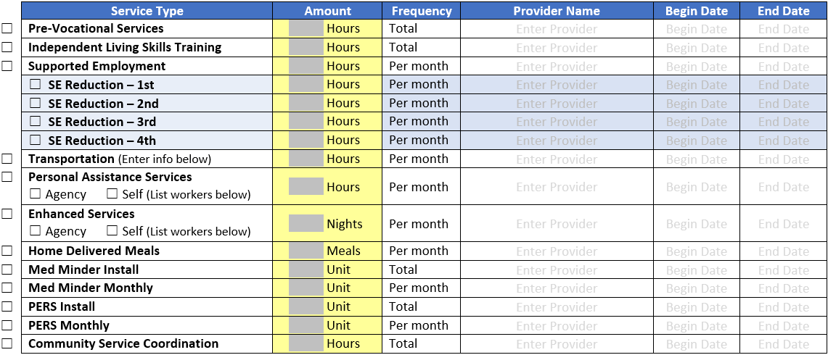
Transportation requires the CSC to identify what type of transportation the member will be utilizing on the next table. If they will be utilizing an agency, you will list them in the Services Table as well as in the Transportation table.
The delivery model for Personal Assistance Services and Enhanced Services needs to be identified as either Agency or Self. If an agency is providing PAS, enter the Provider Name in the table. For self-directed PAS, the worker information will need to be entered in the corresponding section below.

Transportation Table
Enter the total number of assessed hours for transportation from the STEPS Services Assessment in the yellow box at the top of the table. This will calculate the total dollar amount available for transportation costs.
If the member will be utilizing Agency transportation, enter the provider under Vendor/Agency or Member – Who is to be paid. The method of payment for Agencies must be listed as Invoice. The agency must also submit supporting documentation of the transportation provided to the member. List this information under Description/details of transportation. Enter the Monthly Cost where indicated.
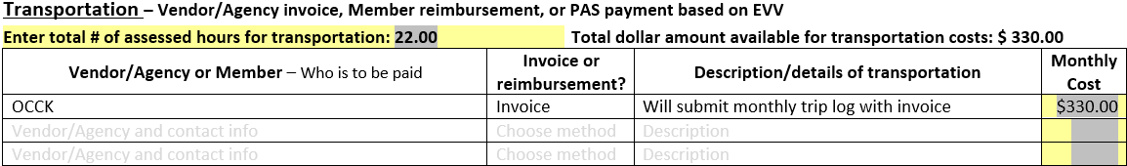
If the member will be utilizing ride share (e.g., Lyft or Uber), taxi, or purchase of a bus passes, enter the member’s name under Vendor/Agency or Member – Who is to be paid. The method of payment for utilizing these services is always listed as Reimbursement. The member will need to submit Reimbursement forms to the FMS along with copies of any receipts (i.e., screenshots for Lyft, receipts for the purchase of a monthly bus pass).
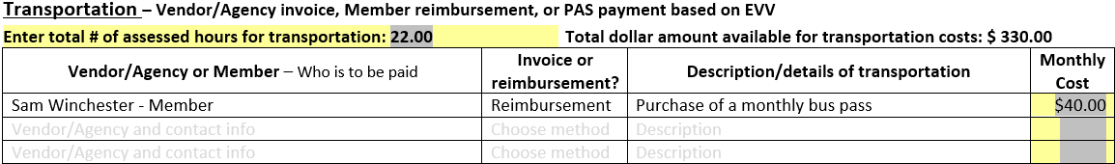
If the member will be utilizing a self-directed PA support, use the PAS Transportation section. Enter the name of the PA or PAs that will be providing transportation to the member. Next choose their Relationship to the member from the drop down. Then enter the number of hours per month each PA will provide transportation. Lastly enter the appropriate hourly wage from the Provider Pay Rates chart.
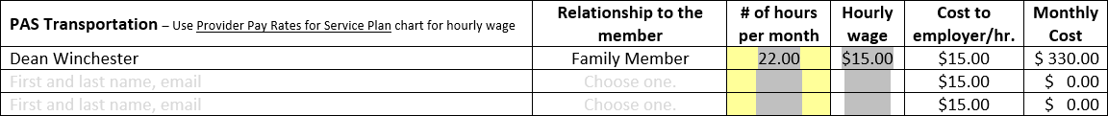

Page 3

Personal Assistance Services (PAS) – Self-Directed
Enter the total number of assessed monthly PAS hours from the STEPS Services Assessment in the yellow box at the top of the table.
Enter the name of the PA or PAs that will be providing in-home supports to the member. Next choose their Relationship to the member from the drop down. Then enter the number of hours per month each PA will provide. Lastly enter the appropriate Hourly Wage from the Provider Pay Rates chart. The total hours per month should equal, but NOT exceed, the total number of assessed hours.

Any backup PAs should also be listed in this table so that they can be entered into the FMS in case they need to provide emergency backup care if the primary PA doesn’t show. Do NOT list any hours for this PA.
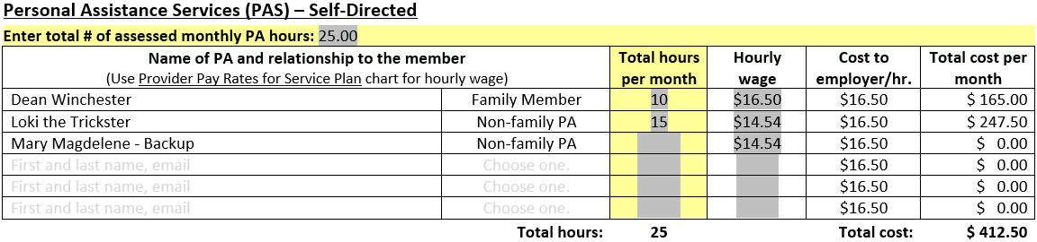
Enhanced Services – Self Directed
This table is treated very similarly to the PAS – Self-Directed table. However, instead of the number hours enter the number of Nights per month from the STEPS Services Assessment in the yellow box at the top.
Enter the name of the PA or PAs that will be providing overnight in-home supports to the member. Next choose their Relationship to the member from the drop down. Then enter the number of nights per month each PA will provide. Lastly enter the appropriate Nightly Rate wage from the Provider Pay Rates chart. The total nights per month should equal, but NOT exceed, the total number of assessed nights.
Any backup PAs should also be listed in this table so that they can be entered into the FMS in case they need to provide emergency backup care if the primary PA doesn’t show. Do NOT list any time for this PA.
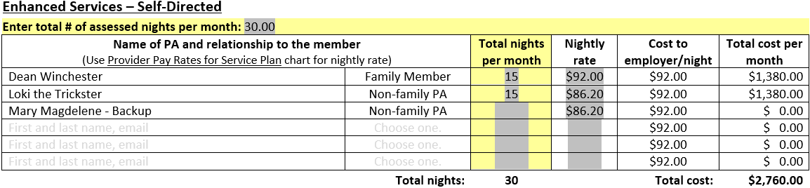

Supplemental Services – Services in place of PAS hours
Only members that have Supplemental Services on their approved STEPS Services Assessment can receive these services. Check the appropriate box for any Supplemental Services that the member will receive.
There is no place to enter a provider as that should have been entered on the Services Table. The information for Home Delivered Meals should transfer from the Services Table to this table.
Enter any 1-time costs associated with the corresponding service, such as PERS or Med Minder Installation. Once these services have been installed, they should be removed from the Service Plan at the next revision.
Enter the total cost per month for any associated monthly fees to maintain these services.
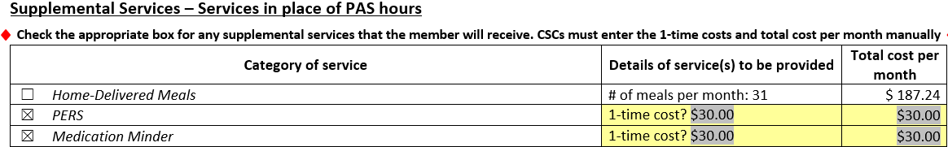

Page 4

Service Plan Summary
The Service Plan summary outlines the costs for all services listed on the Service Plan. Some services show only the total cost because they are not authorized in monthly increments. Pre-Vocational Services and Independent Living Skills Training are limited to 34 hours total for the duration of the service plan.
1-Time costs are also not authorized in monthly increments. However, in the Services Table these should be authorized for a couple of months to allow time for the installation/activation of the service. Once these services have been installed, they should be removed from the Service Plan at the next revision.
There is NO total monthly service cost since not all services are authorized on a monthly basis.
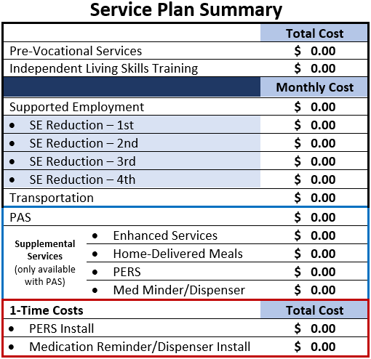

Page 5

STEPS Service Plan Agreement
The STEPS Service Plan Agreement outlines the member and/or their guardian/representative’s agreement to services as outlined on the Service Plan. It also outlines what members can and cannot do with their Services Plans as well as their responsibilities and expectations as members of the STEPS program.
This page must be signed and dated by the Member or guardian/representative and the MCO Care Coordinator assigned to them. The Service Plan is not considered approved and valid until the MCO has signed off and returned the Plan to the CSC.

