STEPS Services Justification Form Instructions

Purpose of the Justification Form
The STEPS Services Justification Form is used to request additional Pre-Vocational, Independent Living Skills Training, and/or Supported Employment hours beyond the limits listed in the STEPS Program Policy Manual. KDHE recognizes that some members may require more time to learn and internalize what they’ve learned than others. These skills are are important for long-term success in employment and living as independently as possible.
For members receiving Pre-Voc or IL Skills Training, once the member has used 28 hours out of the 34 original hours of one or both services and it’s become apparent that the member needs more time to learn these skills, the provider of those services should complete the STEPS Services Justification Form. Pre-Voc and IL Skills are not authorized in monthly amounts. The amount requested will be the amount to be used over the course of the Service Plan period. Members requiring more than an additional 34 hours (68 hours total), or it takes longer than 6 months to use 34 hours may require increased scrutiny by the KDHE STEPS Program Manager.
Supported Employment hours may only exceed the maximum of 13.25 hours per month once a member becomes employed. When a member is getting close to achieving employment and/or once there is a rough schedule of how many hours per week the member will be working, the provider of those services should complete the STEPS Services Justification Form. If a Justification Form cannot be completed early enough in the month for the Service Plan to be increased the following month, then the provider may use any remaining Pre-Vocational hours (if authorized) to supplement their support of the member until the increase can take effect. Supported Employment can be authorized up to the number of hours that the member is working per month. Any authorization of hours beyond the 13.25 hour per month program maximum are expected to be reduced by at least ¼ every 3 months (e.g., 40 hours per month would be reduced to 30 hours per month after 3 months on the job, to 20 hours after 6 months on the job, to 10 hours after 9 months on the job, etc.).
For the requested hours to be authorized in a timely manner, the Justification Form must be sent to the Community Services Coordinator no later than the 11th of the month prior to the requested effective date.

Member Information
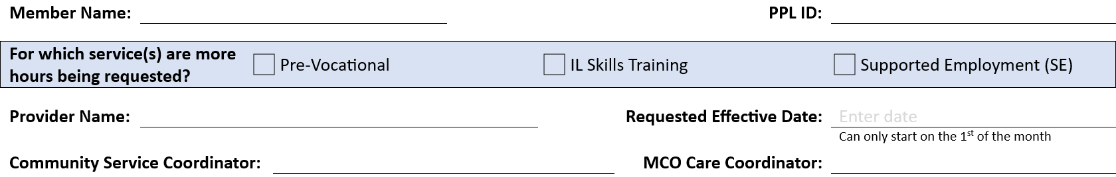
Enter the member’s name and PPL ID to identify who the request is for. Use the check boxes to indicate which service(s) the member needs additional hours for. If the provider is providing more than one of these services, they may use one form to request additional hours for multiple services with the same requested effective date.
Enter the provider’s name, the CSC’s name and the MCO Care Coordinator’s name along with the requested effective date for the new hours to start.

What goals were achieved and/or what skills were learned with the services already provided?
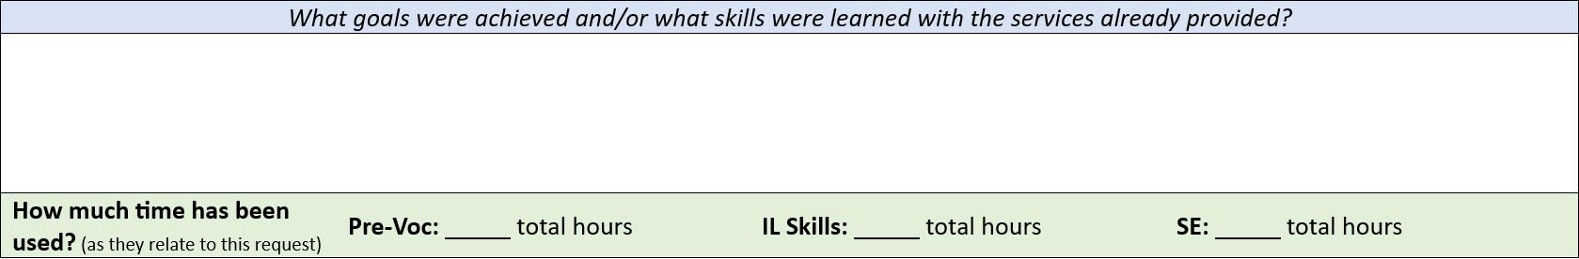
The service provider will enter a concise description of the services already provided to the member and the skills the member has acquired through those services. If the provider is requesting hours for more than one service, please use more than one paragraph and indicate what skills were achieved with each service. Attaching copies of case notes/ progress notes is also acceptable to replace the narrative description.
Use the green box to identify how many hours were used for each service for which more hours are being requested. If not requesting more hours, leave that service’s hours blank or put “N/A.”

Why are additional hours of support being requested?
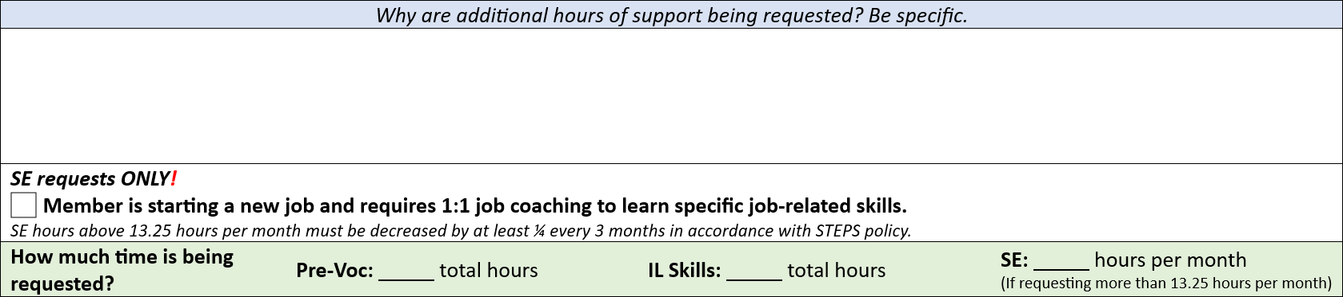
The service provider will enter a description of why they are requesting additional hours on behalf of the member for each service. If a provider is requesting hours for more than one service, please use more than one paragraph to indicate why additional hours are being requested. This description should include a brief list of skills to be addressed and any noted barriers for the member in learning these skills. Barriers could include, but are not limited to: takes longer for them to process information, information has to be repeated several times until it “sticks”, etc. Issues such as repeatedly missing scheduled meetings/classes, not responding to the provider, frequent rescheduling, etc., would not be considered barriers and may be an indicator that the member is not fully invested in seeking employment.
For requests of Supported Employment hours beyond the program limit of 13.25 hours per month because the member will be starting a new job, the provider should also check the SE requests ONLY! box. Checking this box does not replace providing a description of what supports the member needs.
Use the green box to identify how many additional hours are being requested for each service the Justification Form applies to. Pre-Voc and IL Skills hours can be requested up to another 34 hours. Supported Employment may be requested up to the number of hours the member will be working per month. If not requesting more hours, leave that service’s hours blank or put “N/A.”

Services Justification Form Signature Page
All Services Justification Forms require the requesting Service Provider’s signature and date, the CSC’s signature, and the MCO Care Coordinator’s signature for approval. Only requests for additional Pre-Vocational and/or IL Skills hours require the KDHE STEPS Program Manager’s signature.
The Service Provider making the request will submit the Justification Form to the CSC and the MCO Care Coordinator for approval and signatures. For Pre-Voc and IL Skills requests, the MCO will send the Justification Form to the KDHE STEPS Program Manager for approval. Once all approvals have been received, the CSC will develop a Revised Individualized Service Plan reflecting the requested changes and submit to the MCO for entry of authorizations into the FMS system.

