**Working Healthy Benefit Specialist Regional Map**

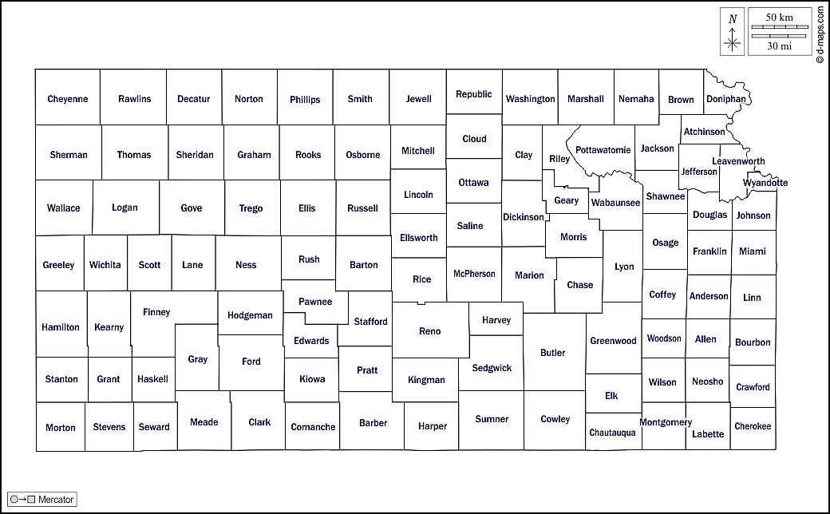

**Billie Crawshaw, SW KS**

**785-261-6122**

**Abby Cooper, NW KS**

**785-515-6710**

**Carol Doss, NE KS**

**785-261-6122**

**Sarah Guardado, Sedgwick County**

**316-337-6409**

**Melissa Fund, EC KS**

**620-704-0353**

**Justine Culver, Shawnee & Douglas**

**785-330-8607**

**Shelli Nyambane, SE KS**

**620-860-7240**

**Billie Crawshaw, WH SR Manager**

**785-261-6122**