Supports and Training for Employing People Successfully

STEPS
Program Policy Manual

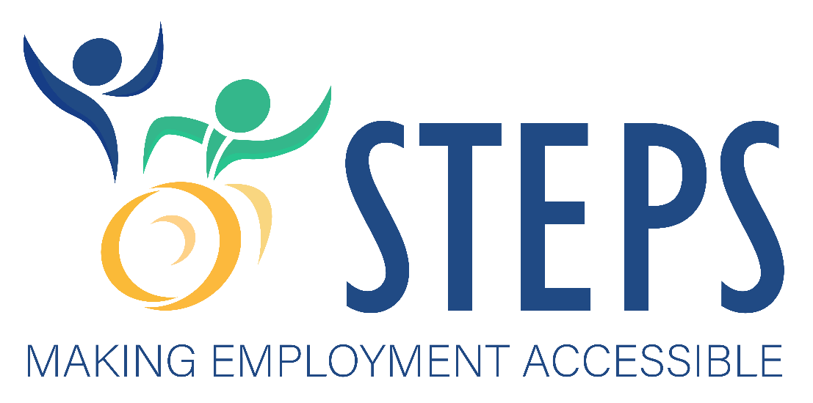
Kansas Department of Health and Environment
Division of Health Care Finance
Working Healthy Program
900 SW Jackson, Suite 900N
Topeka, KS 66612

This manual and all of the STEPS forms are available online at:
https://kancare.ks.gov/consumers/working-healthy/steps

Table of Contents
1. Overview 1
2. Administration 1
3. Target Populations 1
4. Pilot Evaluation 1
5. Enrollment Threshold 2
6. Benefits Planning 2
7. Employment Requirements 2
8. Needs Assessment 2
9. Safety Net 3
I. ELIGIBILITY 4
A. Disability Eligibility 4
B. Financial Eligibility 4
II. ENROLLMENT 6
A. Participant Enrollment 6
B. Provider Enrollment 7
III. ASSESSMENT PROCESS 7
A. Activities of Daily Living and Instrumental Activities of Daily Living 7
B. Risk Assessment 8
C. Limitations 8
IV. STEPS SERVICES 9
A. Services, Descriptions, Maximums, Rates 9
B. Service Plan 30
C. Emergency Back-Up Plan 30
V. RESPONSIBILITIES 31
A. STEPS Program Manager 31
B. Working Healthy Benefits Specialists 32
C. Managed Care Organizations 33
D. MCO Care Coordinators/Case Managers 34
E. Community Services Coordinators 35
F. Fiscal Management Services Provider 37
VI. LOSS OF EMPLOYMENT/TEMPORARY UNEMPLOYMENT PLAN 38
VII. DISENROLLMENT 38
A. Voluntary Disenrollment 38
B. Involuntary Disenrollment 39
VIII. GRIEVANCES, APPEALS, FAIR HEARINGS, STATE APPEAL COMMITTEE, JUDICIAL REVIEW 39
A. MCO Grievance/Appeal Process 39
B. State Fair Hearing 41
C. KDHE State Appeals Committee (SAC) 41
D. Judicial Review 42
IX. KANCARE OMBUDSMAN 42
Appendix A. 43
Service Plan 43
Appendix B. 49
Emergency Backup Plan 49
Appendix C. 52
Working Healthy Benefits Specialist Talking Points 52
Appendix D. 54
Service Codes 54
Appendix E. 55
Acronyms 55

Supports and Training for Employing People Successfully (STEPS)

Overview
STEPS is a voluntary pilot program operating within the Kansas 1115 demonstration called KanCare. STEPS is designed to provide individualized employment and independent living supports available for up to 500 Supplemental Security Income (SSI) and Social Security Disability Insurance (SSDI) beneficiaries who meet pilot eligibility criteria. STEPS purpose is to help the State determine whether providing services designed to support competitive, integrated employment and independent living support result in successful employment and independent living outcomes.

Administration
The Kansas Department of Health and Environment (KDHE) Division of Health Care Finance (DHCF), is responsible for the administration and management of STEPS. KDHE/DHCF is the single Medicaid State agency. Coordinating with participants, MCOs, community providers, other State agencies and the Centers for Medicare and Medicaid Services (CMS), STEPS will operate during the KanCare 2019-2023 demonstration extension, with a possibility of renewal and expansion through an applicable Title XIX authority determined effective.

Target Populations
STEPS is intended for individuals who are currently on certain Home and Community Based (HCBS) waivers or waiting lists that are eligible for SSI and individuals with behavioral health conditions that are eligible for SSI or SSDI who need these services to obtain and maintain employment and independent living skills. Specific criteria is listed under Eligibility. Participants in STEPS will not be eligible for HCBS waivers or duplicative State Plan services. Instead, they will receive individualized pilot services designed to support employment and independent living in the community.

Pilot Evaluation
In addition to evaluation whether providing the right combination of services results in participants obtaining and maintaining employment, KDHE will also evaluate:
- whether participants experience better health outcomes when employed
- whether the need for certain services decrease because of increased independence
- whether participants earnings increase as they continue in the pilot
- whether participants perceive that their quality of life improved during their time in the pilot
KDHE will also compare service costs of a comparable group of individuals on Home and Community Based (HCBS) waivers versus STEPS participants, as well as determine the number of participants whom, if offered an HCBS waiver opening, choose to remain in the pilot.

Enrollment Threshold
KDHE will enroll up to 500 individuals, allowing the pilot program to grow in a controlled manner while assuring appropriate service to participants enrolled in the program. Limiting enrollment will also allow the State to evaluate the effectiveness of the pilot program prior to deciding whether to implement the program under another federal authority.

Benefits Planning
Benefits planning, provided by one of DHCF’s eight certified Benefits Specialists, will be provided prior to enrollment into the pilot. Benefits Specialists assist individuals to understand the impact that employment may have on the benefits they are receiving, such as cash (SSI/SSDI), Medicaid, housing, food and energy assistance. Benefit Specialists can help individuals to explore and utilize work incentives, develop a plan to transition to more frequent paid work thereby increasing income and promote greater independence benefits planning helps by:
- reducing uncertainty about how benefits are impacted by paid employment
- providing information that allows individuals to make an educated choice regarding whether to work and potentially achieve their full work potential
- decrease concerns regarding the loss of medical assistance

The DHCF Benefits Specialists will determine whether individuals are interested in participating in the pilot and notify the STEPS Program Manager if they want to enroll.

Employment Requirements
To receive services via STEPS, participants must be able to achieve and maintain a minimum of 40 hours of employment per month in a competitive, integrated setting. The participant’s employer must be paying the federal hourly minimum wage or more with Federal Insurance Contributions Act (FICA) withheld. Self-Employment, or employment in a sheltered workshop or other congregate setting, does not constitute employment for purposes of this pilot.

Needs Assessment
The State will use a standardized assessment process to determine eligibility and recommend personal assistance services, transportation and independent living skills training. The need for pre-vocational training and supported employment services will be assessed and recommended by the provider of these services.

Safety Net
STEPS will operate with the following provisions:
- Participants who choose to participate in STEPS and are currently on a waiver waitlist will remain on the waiting list and advance based on the date they were added.
- Participants who are offered HCBS waiver services while participating in STEPS are free to choose between STEPS or the HCBS Waiver. If they choose STEPS, they will be considered eligible for the waiver if they are unable to obtain or maintain employment.
- Participants on an HCBS waiver that leave the waiver to participate in STEPS will have the option of returning to that waiver if they are unable to obtain or maintain employment.
If there is a waitlist for STEPS, the list shall be managed by the STEPS Program Manager on a statewide basis based on the day of referral.

ELIGIBILITY

Disability Eligibility
KanCare Participants ages 16 through 64 who meet the following criteria are eligible for STEPS:
- Participants with any of the following behavioral health primary diagnoses and who are eligible for SSI or SSDI benefits and need support to live and work in the community:
      - Schizophrenia;
      - Bipolar and major depression;
      - Delusional disorders;
      - Personality disorders;
      - Psychosis not otherwise specified;
      - Obsessive-compulsive disorder;
      - Post-traumatic stress disorder; or
      - Substance use disorder (SUD) or co-occurring SUD;

- SSI beneficiaries currently enrolled in Medicaid and on the HCBS Intellectual/Developmental Disability (I/DD), Physical Disability (PD), or potential Brain Injury waiting lists
- SSI beneficiaries who are on the I/DD, PD or BI waivers, willing to leave their HCBS waiver and wanting to participate in STEPS. (Priority will be given to individuals on waiting lists if nearing program capacity).

Financial Eligibility
Participants may be eligible for STEPS depending on the financial criteria specified below. Participants may also be required to pay a cost share.
- Individuals with the behavioral health diagnoses listed above who are SSI eligible. There will be no cost share for these participants.
- Individuals who are SSI eligible on the I/DD, PD or BI waiver waiting lists. There will be no cost share for these participants.
- Individuals who are SSI beneficiaries, receiving services on the I/DD, PD or BI waivers and choose to leave their waiver to participate in the pilot. There will be no cost share for these participants.*
- Individuals with a behavioral health diagnosis and who have been determined disabled according to Social Security criteria (e.g. SSDI or Railroad Retirement disability recipients).
- To be financially eligible individuals may have:

      - income up to 300% of current Federal Poverty Level (FPL).
      - resources up to $15,000 for an individual or for a couple.
      - Individuals with income up to 100% of FPL will not have a cost share. Participants with income that exceeds 100% of FPL will be subject to a premium that is consistent with the Kansas Working Healthy program.
      - Premium billing statements will indicate they are for the Working Healthy Program

* Individuals who are SSDI eligible on the I/DD, PD, or BI waivers willing to leave the waiver are Working Healthy eligible and can receive similar support services through the WORK program.

ENROLLMENT

Participant Enrollment
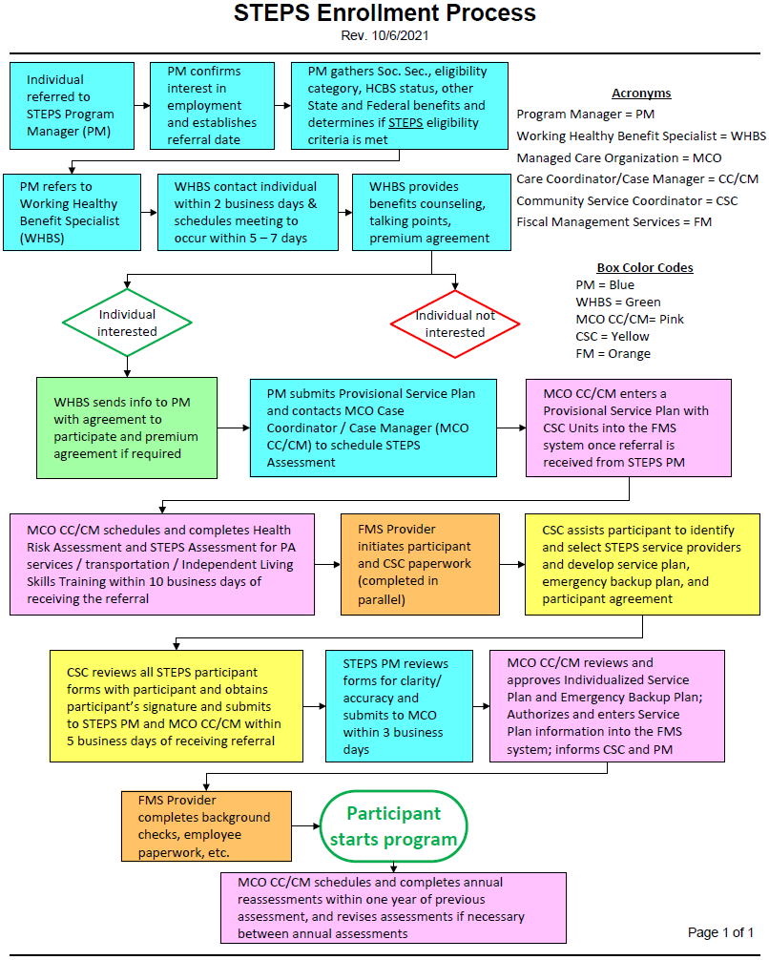

Provider Enrollment
To provide Assistive Services, Agency-Directed Personal Assistance, Community Service Coordination, Independent Living Skills Training, Prevocational Training, Supported Employment and Transportation by a business, providers must enroll to provide these services. Prospective providers should contact the STEPS Program Manager, who will screen to determine whether provider qualifications for these specific services are met. If the provider meets the requirements, the Program Manager will notify the FMS provider. Providers should then follow the process below.
Providing fraudulent information when submitting a request for Medicaid payments is considered Medicaid fraud and abuse and will be reported to the Office of the Kansas Attorney General, Medicaid Fraud and Abuse Unit.
Self-Directed Personal Assistance providers do not require screening by the Program Manager; however, they will have to meet all requirements in the STEPS Policy Manual and pass all required background checks. They can enroll using the process below.

ASSESSMENT PROCESS
Assessment of the need for STEPS services is performed in participants’ homes by MCO Care Coordinators/Case Managers (CC/CMs). During this process, participants are assessed for their need for personal assistance, either hands-on or cued/prompted, based on documented disability/behavioral and/or medical condition. Re-assessments are performed annually. Participants may request a re-assessment at any time if they experience changes in their physical condition(s). The STEPS Program Manager and/or MCO CC/CM may also request a new assessment at any time.

Activities of Daily Living and Instrumental Activities of Daily Living
CC/CMs will assess the need for assistance with Activities of Daily Living, Instrumental Activities of Daily Living and conduct a Risk Assessment. ADLs include bathing, grooming, toileting, transferring, feeding, mobility and health maintenance activities such as monitoring vital signs, supervising and/or training others on nursing procedures, ostomy care, catheter care, enteral nutrition, assistance with or administering medicines and wound care when delegated by a physician or registered nurse in accordance with K.S.A. 65-6201 (b)(2)(A). IADLs include housecleaning, laundry, meal preparation, money management, lawn care/snow removal.
Participants with physical disabilities must demonstrate a need for physical assistance with ADLs in order to receive STEPS services. Participants with intellectual/developmental disabilities or brain injury must demonstrate a need for physical assistance, or cuing/prompting, to perform ADLs and IADLs. Participants with behavioral health conditions will need to qualify for waiver/wait list services in order to be eligible for PAS services.
During assessments, each ADL and IADL will be assessed separately to determine the following:
- Is the participant able to perform this task independently?
- How much time does it require for the member to perform this task independently?
- Does the participant need assistance but currently use unpaid natural supports to perform the task?
- If natural supports are provided, a description of the nature of the natural supports.
- Does the participant need physical assistance to perform the task, and the amount of time this assistance requires?
- Does the participant require cuing and prompting to perform the task, and the amount of time this requires?
- Does the participant require assistance at night?
- Is there an informal support provider* residing in the home?
- Is the expressed need for assistance consistent with the disability and/or medical condition(s)?
Participants and service providers providing fraudulent information regarding their personal needs when submitting a request for Medicaid funding of personal assistance services is considered Medicaid fraud and abuse and will be reported to the Office of the Kansas Attorney General, Medicaid Fraud Control Unit (MFCU). Falsifying the needs for services will also result in removal from the program.

Risk Assessment
CC/CM will assess participants home environment to determine whether any health or environmental risks are present, including:
- home and neighborhood safety
- presence of safety equipment such as carbon monoxide detectors, smoke detectors, and fire extinguishers
- functioning utilities
- emergency egress
- abuse, neglect and/or exploitation issues

Limitations
Participants who reside with an informal support provider, or a person with whom they have a significant relationship, cannot receive personal assistance services for IADLs. *An informal support provider is defined as a person(s) living with a participant(s) with whom they have a significant relationship, e.g., spouses, parents, siblings or children 18 years and older.
Significant relationships include boy/girlfriend, fiancé, partner, and divorced spouse. The informal support provider policy applies whether the residence in which the participant reside is the legal address of the family member or significant other.
Assistance with IADLs including house cleaning, lawn-mowing and snow removal are divided when participants live with a roommate or roommates, even if the residence in which they reside in not the legal residence of the roommate(s).
Paid providers of personal care services, including family members, are not permitted to weigh in or respond to questions during the assessment.

STEPS SERVICES
Services may only be furnished to a waiver participant to the extent that they are not available as vocational rehabilitation services funded under the Rehabilitation Act of 1973. When a state covers prevocational and/or supported employment services in a waiver, the waiver service definition of each service must specifically provide that the services do not include services that are available under the Rehabilitation Act (or, in the case of youth, under the provisions of the IDEA) as well as describe how the State will determine that such services are not available to the participant before authorizing their provision as a waiver service.

Services, Descriptions, Maximums, Rates
Services
Service | Description | Maximum | Rate
Pre-Vocational Services  Service Code: T2047 U3 | Pre-Vocational Services, using a person-centered planning tool, are designed to lead to integrated competitive employment by assisting participants to determine individualized vocational goals, develop or re-establish employment related skills, and participate in internships or work experiences. Person-centered planning tools provide practical strategies for gathering meaningful information and facilitating conversations about goal setting, problem solving and action planning. This process ensures that focus remains on the perspectives of individuals affected by the issue or outcome. Pre-Vocational Services are documented in participants’ person-centered STEPS Service Plans. Pre-Vocational Services are provided for an established period-of-time; this is not an on-going service. Participants and their providers must establish goals, and providers must document progress toward achieving these goals. Providers will be asked to provide their Pre-Vocational curriculum for the STEPS Program Manager to review. All providers must be approved by the Program Manager.  Pre-Vocational Services cannot be provided when participants are receiving these services from other Federal/State entities, e.g., Vocational Rehabilitation, while enrolled in STEPS. STEPS providers are responsible for informing the STEPS Program Manager if they are providing the same or similar services funded by another federal/state entity, such as Vocational Rehabilitation. STEPS participants and their Community Service Coordinators are also responsible for informing the STEPS Program Manager if there is duplication of services funded by another entity.  Billable Services  Career Exploration  - interviewing participant, family members and support network to determine desired outcomes  - identifying participant’s strengths, interests, abilities, aptitudes and learning styles  - assisting participants to identify interests and skills in order to facilitate a job/career of choice in their community  - participating in employment-focused community-based situational work assessments, vocational theme exploration, job shadowing or informational visits to work sites to determine compatibility, likes and dislikes  - assisting with resume development  - assisting to develop interview skills.  Work-Related Skills  - training on skills necessary to obtain and retain employment including punctuality, attendance, appropriate work attire, and appropriate work interactions and behaviors.  Work Experience  - participating in integrated community-based internship programs or similar work experience.  Providers  Community Developmental Disability Organizations (CDDOs), CDDO Affiliates, Community Mental Health Centers (CMHCs), CMHC Affiliates, Centers for Independent Living (CILs), accredited Clubhouse Models, KS Workforce Centers, Brain Injury HCBS providers, and religious-based organizations such as Catholic Charities or Jewish Vocational Services. All providers must be approved by the STEPS Program Manager.  Provider Qualifications  - employee of one of the above listed providers  - experience providing pre-vocational services for individuals with disabilities.  Restrictions  Pre-Vocational Training:  - does not include work experiences in segregated/sheltered settings  - does not include assistance to establish a small business or self-employment  - cannot be provided by family members, relatives, representatives, conservators, guardians, or those with Power of Attorney for participants. | 34 hours in a  3-month period. | $10 per  15-minute unit or $40 per hour
Independent Living Skills Training  Service Code: H2014 U3 | Independent Living Skills (ILS) Training is designed to improve participant’s ability to live as independently as possible at home and in the community using existing community resources. The provision of ILS Training may reduce or eliminate the need for Personal Assistance Services and/or Transportation. Participants and their providers must establish goals, and providers must document progress toward achieving these goals and communicate progress or concerns to participants’ Community Services Coordinators. ILS Training is provided for an established period-of-time and is not ongoing. Providers will be asked to provide their Independent Living Skills curriculum for the State to review. All providers must be approved by the STEPS Program Manager.  ILS Training cannot be provided when participants are receiving these services from other Federal/State entities, e.g., Vocational Rehabilitation, while enrolled in STEPS. STEPS providers are responsible for informing the STEPS Program Manager if they are providing the same or similar services funded by another federal/state entity, such as Vocational Rehabilitation. STEPS participants and their Community Service Coordinators are also responsible for informing the STEPS Program Manager if there is duplication of services funded by another entity.  Billable Services  Assistance to develop the skills necessary to perform the following as independently as possible:  - personal hygiene – bathing, brushing teeth, dressing, and choosing clothes appropriate for the season and for work  - household management – meal planning, cooking skills, cleaning and laundry skills, household safety  - money management – budgeting skills, comparison shopping, managing checking or savings accounts, banking  - medication management – re-filling prescriptions, setting up medications, taking medications at the prescribed time  - organizational skills – scheduling appointments, alternatives for memory loss, creative problem-solving  - locating transportation options and utilizing community transportation independently.  Providers  Community Developmental Disability Organizations (CDDOs), CDDO Affiliates, Community Mental Health Centers (CMHCs), CMHC Affiliates, Centers for Independent Living (CILs), Accredited Clubhouse Models, KS Workforce Centers, Brain Injury HCBS providers and religious based organizations. All providers must be approved by the STEPS Program Manager.  Provider Qualifications  - employee of one of the above listed providers  - experience providing independent living skills training for individuals with disabilities.  Restrictions  ILS Training:  - cannot be provided by family members, relatives, representatives, conservators, guardians, or those with Power of Attorney for participants. | 34 hours in a  3-month period | $8.00 per  15-minute unit or $32 per hour
Transportation Services  Service Code: T2003 U3 | Transportation to and from job interviews, work and essential locations such as grocery stores and banks.  Transportation to and from medical appointments is considered Non-Emergency Medical Transportation (NEMT) and must be obtained from participants MCO transportation contractors.  Transportation cannot be provided while receiving transportation services from other Federal/State entities, e.g., Vocational Rehabilitation, while enrolled in STEPS. STEPS providers are responsible for informing the STEPS Program Manager if they are providing the same or similar services funded by another federal/state entity, such as Vocational Rehabilitation. STEPS participants and their Community Service Coordinators are also responsible for informing the STEPS Program Manager if there is duplication of services funded by another entity.  Billable Services  - transportation for job interviews  - transportation to and from work, grocery shopping and banking.  Providers  - Personal assistants or other individuals selected by participants, agencies or companies providing specialized transportation, companies that provide non-specialized transportation such as buses, taxis, Uber, etc.  Provider Qualifications  - driver’s license  - employee of one of the transportation companies listed above  - personal assistants or other individuals providing this service must have a review of their driving record.  Restrictions  Transportation does not include:  - Non-Emergency Medical Transportation (NEMT)  - paying PAs to provide non-emergency medical transportation (NEMT)  - going to and from leisure time or religious activities  - transportation required to perform job responsibilities, as this is the responsibility of participants employers  - purchase of a vehicle, replacing tires, gas or vehicle repairs. | Up to 10 hours per week | $3.75 per 15-minute unit or $15 per hour
Supported Employment  Service Code: H2023 U3 | Supported Employment includes a number of services which assist participants in obtaining and maintaining employment, including developing relationships with community employers, coordinating with participants, family, Community Service Coordinator and the Pre-Vocational Services provider to determine participants interests and skills, assisting participants to locate employment, determining and requesting needed job accommodations, collaborating with Community Service Coordinators to determine when one-on-one assistance should be decreased or eliminated, trouble-shooting when problems arise, providing technical assistance as needed for participants and/or their employers and documenting efforts. Supported Employment can involve one-on-one assistance to assist participants to become oriented to a new job, learn job responsibilities, practice work-appropriate and safe behavior, etc. Supported Employment is provided up to 13.25 during the first 15 months of participance in STEPS. Following the first 15 months, the MCO Care Coordinator, with input from the Community Service Coordinator, will review the need for Supported Employment quarterly and reduce the number of hours by a minimum of ¼, with a goal of eliminating Supported Employment entirely by the end of the second year. Supported Employment may be re-instated at some level, up to 13.25 hours, for a limited time, if participants require the service to maintain employment or learn new job responsibilities.  Supported Employment cannot be provided when participants are receiving these services from other Federal/State entities, e.g., Vocational Rehabilitation, while enrolled in STEPS. STEPS providers are responsible for informing the STEPS Program Manager if they are providing the same or similar services funded by another federal/state entity, such as Vocational Rehabilitation. STEPS participants and their Community Service Coordinators are also responsible for informing the STEPS Program Manager if there is duplication of services funded by another entity.  Billable Services  - determining participants interests and skills  - locating employment possibilities for participants  - analyzing job tasks to determine suitability for participants  - addressing employer’s concerns regarding hiring individuals with disabilities  - facilitating the hiring of participants by employers  - identifying workplace supports that help participants maintain employment and facilitating additional support as indicated  - negotiating customized jobs for participants  - overseeing and directing Job Coaches  - consulting with, and providing technical assistance for, participants and/or their employers  - communicating and coordinating with participants’ Community Service Coordinators.  - One-on-one supports for the following:  - orienting and training participants to new or evolving job responsibilities  - reminders to practice work-appropriate behaviors  - reminders to interact appropriately with other employees and the public  - reminders to practice safety measures  - support to increase accuracy and/or speed  - support to deal with mental health symptoms  - informing the Community Service Coordinator and Job Coach/Employment Specialist of potential problems  Providers  Employed by one of the following: Community Developmental Disability Organizations (CDDOs), CDDO Affiliates, Community Mental Health Centers (CMHCs), CMHC Affiliates, Centers for Independent Living (CILs), KS Workforce Centers, Accredited Clubhouse Models, Brain Injury HCBS providers and religious based organizations. Community agencies must have staff trained and certified by a national training and certifying body, such as employment specialists, job specialists, job coaches, supported employment specialists, etc., All providers must be approved by the STEPS Program Manager.  Provider Qualifications  - employee of one of the agencies listed above  - experience providing employment support for individuals with disabilities and their employers  - knowledge of the local job market and familiarity with local employers  - certification/licensing/training in any of the following models: Individualized Placement and Supports (IPS), Individualized Discovery/Customized Employment (IDCE), Association of Community Rehabilitation Educators (ACRE) National Certificate in Employment Services, Vermont Progressive Employment (VTPE), Certified Employment Support Professional (CESP); other supported employment models will be considered. Providers will be asked to provide information about their employment model/models  Restrictions  - cannot be provided by family members, relatives, representatives, conservators, guardians, or those with Power of Attorney for participants  - does not include payment for supervision, training, support and adaptations typically available to other workers without disabilities filling similar positions in the business  - cannot go beyond the scope of the Medicaid program or subsume an employer’s responsibilities under Title I of the Americans with Disabilities Act or the Kansas Act Against Discrimination  - cannot be receiving Supported Employment from other Federal/State entities, e.g., Vocational Rehabilitation, while enrolled in STEPS | Up to 13.25 hours per month through the first year of employment. | $12.50 per 15-minute unit or $50 per hour
Personal Assistance Services  Agency-direct: S5125 U3  Self-direct: S5125 U5 | Personal Assistance Services (PAS) are designed to provide hands-on assistance, or cuing and prompting, for Activities of Daily Living (ADLs) and Instrumental Activities of Daily Living (IADLs). Cuing/prompting must be face-to-face. PAs are available to assist participants to perform IADLs, however are not to perform these functions in the absence of the participant. Participants are expected to be present to directly supervise these activities.  PAS also includes alternative and cost-effective methods of obtaining assistance, including:  Enhanced Services (ES) Service Code: T2025 U3 Assistance for participants who require hands-on care during the night, including re-positioning, tracheotomy care, and care for chronic incontinence; need must be documented by a physician. Enhanced Services can be provided as a self-directed or agency-directed service. ES is available to a participant who demonstrates an assessed need for a minimum of 6 hours of sleep support within a 24-hour period and the assessed need cannot be met by the use of personal emergency response services (PERS), and/or informal support. Specific to I/DD, ES may only be authorized when there is a physician’s documented assessed need for overnight support to ensure the health, safety and welfare of the participant. ES is designed to provide supervision and/or non-nursing physical assistance during a participant’s normal sleeping hours. These services must be provided in the participant’s home and the service provider must remain in the participant’s home for the duration of the person’s normal sleep cycle as documented in their assessment. The provider must be able to be awakened and available to provide immediate assistance with tasks such as toileting, transferring, mobility, and medication reminders as needed. The provider must also be able to be awakened and capable of contacting a doctor, hospital, or medical professional in the event of an emergency. Limitations ES cannot be provided by a participant’s spouse, parent, or any individual residing in the home with the participant; however, exceptions may be authorized under the following conditions: - The participant lives in a rural area in which access to a provider is beyond a 50-mile radius from the participant’s home and the family member is the only provider available to meet the participant’s needs - The participant lives alone and has severe cognitive impairment, physical disability, or intellectual disability.  Home-Delivered Meals Service Code: S5170 U3 Meal delivery if determined cost-effective when compared to meal preparation by a personal assistant.  Personal Emergency Response (PERS) Install: S5160 U3 Monthly: S5161 U3 Personal Emergency Response Systems (PERS) allowing participants to seek help when alone.  Medication reminder/ dispenser install  Service Code: T1505 U5  Medication reminder/ dispenser monthly  Service Code: T1505 U3  Personal Assistance Services cannot be provided when participants are receiving these services from other Federal/State entities, e.g., Vocational Rehabilitation, while enrolled in STEPS. STEPS providers are responsible for informing the STEPS Program Manager if they are providing the same or similar services funded by another federal/state entity, such as Vocational Rehabilitation. STEPS participants and their Community Service Coordinators are also responsible for informing the STEPS Program Manager if there is duplication of services funded by another entity.  Billable Services  Hands-on assistance, or cuing and prompting, with any of the following ADLs and IADLs:  - bathing, dressing, toileting, transferring;  - meal preparation, grocery shopping, light housekeeping, laundry;  - medication reminders;  - feeding, watering and, if appropriate, walking one service animal (participants must be able to demonstrate the services performed by the animal during the assessment).  Providers  Participants who choose to self-direct their services may choose whom they want to provide their PAS and are free to establish the qualifications for their PAs; however, they must follow all STEPS policies related to personal assistants. Participants are strongly encouraged to obtain references from previous employers, as well as personal references.  Participants who self-direct their services are the employer-of-record.  Participants may also choose an agency to provide their services or choose to have a combination of self- and agency-directed services. Agency Personal Assistants (PAs) are employees of the agency.  Provider Qualifications  PAs, whether self or agency-directed, must meet the following criteria:  Age - PAs must be 18 years of age or older to provide paid support for ADLs. PAs who are 14-18 years of age may provide paid support for IADLs at the following level:  - 3 hours on a school day;  - 18 hours in a school week;  - 8 hours on a non-school day;  - 40 hours in a non-school week; and  - between 7 a.m. and 7 p.m., except from June 1 through Labor Day, when nighttime work hours are extended to 9 p.m.  Background Checks – PAs, whether self- or agency-directed, are required to pass State and National criminal history background checks. Community Service Coordinators must confirm that background checks have been conducted on agency-employed PAs. Individuals without clear background checks may not provide PAS for participants. Background checks include:  - Kansas Bureau of Investigation;  - Kansas Adult Abuse, Neglect, Exploitation Central Registry and/or Child Abuse and Neglect Central Registry;  - Nurse Aid Registry;  - Motor Vehicle screen.  Restrictions  - participants’ representatives, conservators, guardians and those with Power of Attorney for participants may not provide PAS  - assistance with IADLs is not provided for participants who are performing similar tasks at their place of employment  - care may not be provided for participant’s minor children or other family members  - support is not provided for monitoring food intake, internet/telephone usage, or other restrictive measures  - cleaning, maintaining or repairing vehicles  - care of pets  - care of emotional support and/or comfort animals is not provided as these are not considered service animals under the Americans with Disabilities Act  - participants may live in a provider operated home; however, the operator of the home cannot provide participants PAS  - verifying payment for services that were not provided (STEPS services may be terminated, and a report made to the Office of the Attorney General Medicaid Fraud Control Unit (MFCU)  - paying more than one PA at a time unless approved by the STEPS Program Manager  - receiving Personal Assistance Services from other Federal/State entities, e.g., Vocational Rehabilitation, while enrolled in STEPS. | PAS – Can be no more than 24-hours per day (Including Enhanced Services)  Enhanced Services – Maximum is dictated by number of nights in a given month  Home-delivered meals – Up to 2 meals per day  PERS – up to 2 installs per year  Medication reminder – 1 install per year | PAS – $4.125 per 15-minute unit or $16.50 per hour (base rate)  Enhanced Services – Flat fee of $85 per night of support  Home-delivered meals – $6.04 per meal  PERS – Up to $40 per month monitoring + one-time installation fee  Medication reminder – Up to $30 per month + one-time installation fee
Assistive Services  Assist. Tech. / Home Mod: S5165 U3  Vehicle Mod: T2039 U3 | Assistive Services includes equipment, product systems, or environmental and home/vehicle modifications that are medically necessary, increase health, safety, independence, and employability and are not already provided by KanCare as a Kansas Medicaid State Plan service. There is no entitlement for assistive services. Each Assistive Service request is reviewed on a case-by-case basis, taking into consideration medical necessity, appropriateness and cost-effectiveness. The request is then approved or denied by the STEPS Program Manager. If approved, the MCO will prior authorize the purchase in the FMS system. Assistive Services has an annual cap of $7,500. Assistive Services is not an entitlement; participants are not entitled to receive $7,500 per year, nor does the annual cap transfer, or accrue, from year-to-year. Assistive Services cannot be authorized retroactively. If complete paperwork is not submitted for approval by the STEPS Program Manager and prior authorized by the MCO, payment will be denied. Participants must provide documentation of medical necessity for the assistive service.  Medical necessity is defined as:  - treating a medical condition  - recommended by the treating physician or other appropriate licensed professional in the area of expertise (a medical practitioner cannot establish medical necessity outside his/her area of expertise)  - providing the most appropriate level of service considering potential benefits and harms to the individual  - known to be effective in improving health outcomes  - cost-effective for the condition being treated when compared to alternative interventions (the usual and customary rate is used when approving assistive services).  To request an assistive service, the STEPS Request for Assistive Services form must be completed and submitted to the Program Manager with the following:  - a statement of medical necessity from the appropriate medical provider;  - alternative funding sources that have been explored and why these are not viable;  - a minimum of two bids;  - pictures and/or diagrams, if requested by the STEPS Program Manager.  All Assistive Services Request packets must be submitted in full in order to be processed. Failure to provide all required information and documentation will result in an immediate denial. Once all paperwork listed above has been submitted, the Program Manager will have 20 business days to approve or deny the request. Omission of any of the above paperwork will result in a denial at the 20-business day deadline. Participants will be required to re-submit all required paperwork, and the 20 business days for approval or denial will begin again.  Assistive Services cannot be provided when participants are receiving these services from other Federal/State entities, e.g., Vocational Rehabilitation, while enrolled in STEPS. STEPS providers are responsible for informing the STEPS Program Manager if they are providing the same or similar services funded by another federal/state entity, such as Vocational Rehabilitation. STEPS participants and their Community Service Coordinators are also responsible for informing the STEPS Program Manager if there is duplication of services funded by another entity.  Billable Services  Examples of Assistive Services include:  - dentures  - home modifications to increase access in the participant’s home, including grab bars, raised toilet seats, roll-in showers, lowered counters  - ramps (removal of porches or decks and/or adding porches or decks are the financial responsibility of the participant)  - emergency alert installation  - environmental control units (to control items within the home such as lights or door locks)  - electric lifts  - hearing aids and batteries  - insulin pumps and pump supplies  - low vision aids for home use  - wheelchair seating and positioning  - specialized wheelchairs  - wheelchair or scooter batteries and repairs  - specialized footwear (Diabetic, Orthopedic)  - hospital beds  - mattresses, mattress covers, and bed rails used in medical situations  - cost of obtaining and replacing accredited service dogs and other accredited service animals  - vehicle adaptations, based on the participant’s disability  - services which directly assist individuals with a disability in the selection, acquisition, or use of assistive technology.  Providers  Durable Medical Equipment (DME) vendors, dentists, orthotics and prosthetics vendors, Community Developmental Disability Organizations (CDDOs) and affiliates of CDDOs, Centers for Independent Living (CILs), and licensed Home Health Agencies. Providers must be approved by the STEPS Program Manager.  Provider Qualifications  Agencies and businesses meeting the certification, licensing, requirements and qualifications of the providers listed above.  Restrictions  Excluded items include, but are not limited to:  - food or nutritional supplements  - clothing  - shoes of a non-medical nature  - computers, laptops, iPads/tablets, cell phones  - environmental units such as air conditioners, furnaces, space heaters humidifiers/de-humidifiers, air purifiers, water purifiers  - appliances such as blenders, microwaves, refrigerators, washers, dryers  - exercise equipment  - indoor/outdoor exercise pools  - heating pads, heat lamps, vaporizers  - home renovations not related to accessibility  - hot tubs, Jacuzzis, saunas, spas, whirlpools, swimming pools, or similar items  - yard cleaning, yard repairs  - surgeries not already covered under KanCare  - non-medical beds and water beds  - household furniture  - recliners  - home remodeling, including but not limited to movement of walls, replacement of carpets or floors, painting, etc.  - vehicles and vehicle repairs  - modifications to buildings in which the participant does not reside, e.g., garages and sheds  - adding or repairing fences or out-buildings  - adding, removing, or replacing decks or porches  - assistive technology and durable medical equipment covered under the Kansas Medicaid State Plan  - assistive technology to allow or improve access at the place of employment;  - durable medical equipment (DME) or other technology provided by KanCare (Kansas Medicaid State Plan services), nor will it extend the amount, duration or scope of technology specified in the Medicaid State Plan  - technology or modifications that are the responsibility of the employer as an accommodation under the Americans with Disabilities Act (ADA). | Annual maximum $7,500 | Based on cost of request upon approval by Program Manager
Community Service Coordination  Service Code: T1016 U3 | Assisting participants to make program choices, locate and direct services, develop and obtain approval for Emergency Back-Up Plans, perform fiscal management responsibilities, completing paperwork; monitoring services and progress to complete goals; communicating progress and concerns with MCO Care Coordinators/Case Managers, and Employment Specialists, linking and referring participants to community resources and non-Medicaid supports such as education, employment, and housing. All assistance must be documented in a form provided or approved by the STEPS Program Manager. Documentation must be provided at the request of the Program Manager within one business day of the request. Community Service Coordinators (CSCs) are expected to provide conflict-free service coordination, always considering the best needs and interest of participants and not the agency with which they are affiliated.  Community Service Coordination is to be billed in units of 15 minutes (i.e., 1 unit = 15 minutes). CSCs can bill up to 40 units (10 hours) during the 30-day period prior to enrollment in STEPS.  Providing fraudulent information when submitting a request for Medicaid funding of assistive services, or selling items that were purchased with Medicaid funds, is considered Medicaid fraud and abuse and will be reported to the Office of the Kansas Attorney General, Medicaid Fraud and Abuse Unit.  STEPS participants cannot receive Targeted Case Management (TCM) under the Kansas Medicaid State Plan or a Home and Community Based Services Waiver. Community Services Coordination cannot be provided when participants are receiving these services from other Federal/State entities, e.g., Vocational Rehabilitation. STEPS providers are responsible for informing the STEPS Program Manager if they are providing the same or similar services funded by another federal/state entity, such as Vocational Rehabilitation. STEPS participants and their Community Service Coordinators are also responsible for informing the STEPS Program Manager if there is duplication of services funded by another entity.  Billable Services  - facilitating participants understanding of the STEPS program and the use of program services  - actively coordinating with the MCO CM/CC, STEPS Program Manager, Working Healthy Benefits Specialists, Employment Specialists, community partners and other State agencies to ensure optimum service provision and that participants needs are met  - assisting members to access one of the two on-line training programs provided on the Working Healthy website, or other available tools  - assisting participants to locate providers of personal assistance and to enroll them as providers in the STEPS FMS system  - assisting participants to interview, hire, supervise, and terminate personal assistants  - assisting members to locate providers of transportation  - assisting participants to locate providers of alternative services such as PERS and meal support, as well as assisting participants to terminate alternative services  - assisting members to document and submit requests for reimbursements to the FMS provider in a timely manner  - assisting participants to access Independent Living Skills and Pre-Vocational training, Supported Employment resources, obtaining service recommendations from appropriate community providers and conveying these to MCO CC/CMs for incorporation into participants’ Service Plans  - assisting participants to obtain safety equipment within their home  - assisting participants to develop an Emergency Back-Up Plan that is viable and includes all criteria specified in the STEPS Program Manual  - obtaining approval for the Emergency Back-Up Plans from the MCO CC/CM  - assisting members to coordinate Non-Emergency Medical Transportation (NEMT)  - monitoring the provision of services and ensuring that participants are receiving the services they need and are progressing in training that they are receiving  - requesting an increase or decrease of services, as appropriate, from the STEPS Program Manager  - monitoring services to ensure that they are being provided appropriately within the scope of the program  - assisting with completing the Request for Assistive Services paperwork; facilitating requests for approval of assistive services from the STEPS Program Manager  - referring participants to other resource agencies as needed to address needs that contribute to the social determinants of health  - assisting participants with paperwork to access other services e.g., Vocational Rehabilitation, affordable housing, etc.  - assisting participants to locate volunteer services if needed, e.g., to attend church, leisure activities, etc.  - assisting participants to complete annual Medicaid eligibility paperwork and six months desk review, if applicable  - requesting a mid-assessment revision of the Service Plan based on participant’s needs or complete re-assessment at any time participants experience dramatic changes in their physical or behavioral conditions  - communicating any changes in status, needs, problems, etc., to participants MCO CC/CM  - documenting all contacts with participants, following the State’s documentation requirements  - notifying the STEPS Program Manager and the MCOs CC/CMs when it appears participants are not capable of self-directing services and require representatives and/or agency directed services or if they lose employment  - notifying the STEPS Program Manager if participants are not participating in the Pre-Vocational and/or Independent Living Skills training  - notifying the STEPS Program Manager when a participant becomes employed or unemployed  - reporting health and safety concerns to the STEPS Program Manager and MCOs CC/CMs when it appears participants health and/or safety are in jeopardy  - reporting to the STEPS Program Manager when participants and/or personal assistants are not following STEPS program policies and procedures  - reporting emotional abuse, physical abuse, exploitation, fiduciary abuse, maltreatment and/or neglect of participants to the STEPS Program Manager, MCO CC/CMs and the Division of Children and Families (DCF) Adult Protective Services.  Providers  Community Developmental Disability Organizations (CDDOs), CDDO Affiliates, Community Mental Health Centers (CMHCs), CMHC Affiliates, Centers for Independent Living (CILs), Accredited Clubhouse Models, Brain Injury HCBS providers and religious based organizations. All providers must be approved by the STEPS Program Manager.  Provider Qualifications  - employee or affiliate of one of the above listed organizations  - experience providing case management, Targeted Case Management, care coordination  - ability to provide conflict-free service coordination.  Restrictions  Community Service Coordinators (CSCs) cannot:  - direct participants to the agency for which they work or are affiliated with for services without considering participant’s best interests  - provide personal assistance services for participants, or allow family members to provide personal assistance for participants for whom they are the CSC  - act as a representative, guardian, or POA for any STEPS member on their caseload, receiving services from the CSC’s privately-operated agency, or receiving services by the agency for which the CSC is employed.  - handle, or be involved with, any personal funds of participants including, but not limited to, cash, checking and savings accounts, and premium payments  - have substantiated prohibited offenses as listed in KSA 39-970 & 65-5117 as they would not be eligible for reimbursement of services under Medicaid funding.  - bill for the following:  - advocacy  - assistance with, or testifying at, appeals  - travel  - anything not specified in the STEPS Policy Manual under Community Service Coordinator Responsibilities. | Up to 480 units or 120 hours per calendar year | $12.50 per 15-minute unit or $50 per hour.
Fiscal Management Services | A Fiscal Management Services vendor manages funds used to pay for STEPS services. |  | $125 per member per month

Service Plan
Based on the assessment, and in conjunction with participants, CSCs will develop a STEPS Service Plan. CC/CMs will determine the amount of personal assistance necessary for each task, and the total amount of assistance for all tasks combined. CC/CMs and participants may substitute alternatives to human assistance such as a medication management system, personal emergency response system or home delivered meals when it contributes to independence and/or it is cost effective. In some cases, CC/CMs will recommend that participants receive Independent Living Skills Training to reduce or eliminate the need for personal assistance services. CC/CMs may also indicate the need for the installation of safety equipment or assistive technology.
CC/CMs will then refer participants to their Community Service Coordinators (CSCs) to locate providers of Independent Living Skills Training, Prevocational Training, and Supported Employment, as needed. All services are then included in the STEPS Service Plan, which must be signed by participants before being entered into the Fiscal Management Services (FMS) system. See Appendix A – STEPS Service Plan.

Emergency Back-Up Plan
Participants are required to have an Emergency Back-Up Plan. CSCs can assist in the development of Emergency Back-Up Plans. Emergency Back-Up Plans must contain:
- name(s) and contact information of person(s) that will provide emergency back-up assistance in the event a personal assistant does not report to work
- name(s) and contact information of persons that should be notified in the event of an emergency
- evacuation plans in the event of a fire or natural or man-made disaster, including whether personal assistants or local emergency personnel have agreed to assist in the evacuation process
- for members dependent on technology, how their technology will be powered in the event of a power outage
- for members with service animals or pets, how the animal(s) will be cared for in the event of a hospitalization or emergency
Emergency Back-Up Plans must include individuals, or agencies, that are aware of, and have agreed to, provide assistance in the event that personal assistants are unable or unwilling to perform their job duties. Those listed in the Plan must be located within the same area as the member; they cannot live in another area of the state or out-of-state. See Appendix B – STEPS Emergency Backup Plan
The Emergency Back-Up Plan is submitted to the MCO CC/CM for approval. The CC/CM will review the Emergency Back-Up Plan to determine whether the emergency provisions are adequate. If not, participants and CSCs may be asked to review and revise the plan.

RESPONSIBILITIES

STEPS Program Manager
The Program Manager is responsible for overseeing day-to-day operation of STEPS, including:
- facilitating enrollment into the program, orientating participants, coordinating with participants, community providers, KDHE field staff, KDADS waiver staff, DCF Vocational Rehabilitation staff, MCOs designated STEPS contacts and STEPS Care Coordinators/Case Managers (CC/CMs)
- facilitating dis-enrollment from the program and returning to Home and Community Based Services (HCBS) waiting lists or waivers, as appropriate
- notifying Benefits Specialists of enrollment/disenrollment to enable them to communicate with KanCare Clearinghouse eligibility staff
- developing and maintaining a waiting list database as needed
- providing STEPS training for MCOs CC/CMs, Community Service Coordinators (CSCs) and other service providers
- confirming that STEPS services providers meet all requirements established by the Division of Health Care Finance (DHCF), and maintaining this information in a database
- notifying the Fiscal Management Service (FMS) provider when a STEPS service provider is approved
- maintaining a database of STEPS providers, and providing this information to the MCO designated STEPS contact, CC/CMs and CSCs each time this is updated
- ensuring that there is no conflict of interest on the part of the Community Service Coordinators, including but not limited to:
  - directing participants to the agency or organization that employs them without considering other service providers
  - providing services for their family Participants, relatives or friends
  - allowing their family Participants or relatives to provide STEPS services for participants
- ensuring that CSCs receive training provided by the State before coordinating STEPS participants services
- verifying CSCs participation in 12 hours of training during a calendar year
- verifying credentials and/or curriculum of service providers of Pre-Vocational Training, Independent Living Skills Training, and Supported Employment
- verifying that home health agencies providing STEPS Personal Assistance Services (PAS) are licensed by the State and that they conduct background checks on providers of PAS
- reviewing participants STEPS assessments and notifying the CC/CMs of any issues within three business days of receiving them, ensuring that:
  - participants need for assistance is being met
  - service recommendations are within the amount, duration and scope specified by the STEPS Policy Manual
- reviewing Service Plans and Emergency Back-Up Plans within three business days of receiving them, and notifying the CC/CMs of any issues
- approving or denying of Assistive Service requests submitted by CSCs on behalf of participants; decisions regarding Assistive Service will be made within 20 business days if all required paperwork has been submitted
- approving or denying requests by CSCs, on behalf of participants, to increase service maximums between annual assessments
- notifying MCO CC/CMs if approved, allowing them to enter the increase into the FMS system
- providing technical assistance related to assessments, Service Plans, fiscal management, etc., for MCO CC/CM and CSCs
- facilitating the resolution of participants and service providers concerns
- reviewing fiscal management reports provided by MCOs and their FMS subcontractors for thoroughness and accuracy
- maintaining a database of STEPS participants by MCO, including demographic and program data, HCBS waiting list/waiver status, enrollment and disenrollment, service utilization and costs, etc.
- notifying MCOs when participants change MCOs
- developing and providing timely and accurate reports to DHCF and CMS as requested
- assisting the Director in developing policies and procedures to meet the needs of the program participants and providers, as well as to meet State and Federal regulations

Working Healthy Benefits Specialists
Working Healthy Benefits Specialists are responsible for the following:
- meeting with potential STEPS participants referred by the Program Manager to explain how employment and earnings will impact benefits, including but not limited to Supplemental Security Income (SSI), Social Security Disability Insurance (SSDI), Medicaid, as well other State and Federal benefits as appropriate
- discussing premiums, when applicable, and obtaining participants agreement, in writing, to pay premiums in order to participate in the program
- obtaining participants signed agreement to be enrolled in the program
- notifying the Program Manager of meeting outcome
- forwarding participation and premium agreements to Program Manager
- responding when participants have additional questions regarding their benefits and employment
- initiating Temporary Unemployment Plans (TUPs) when participants lose employment; tracking whether they become re-employed or unable to obtain employment
- notifying the KanCare Eligibility Clearinghouse via the Working Healthy queue when participants enroll and disenroll
- educating people about the STEPS program and referring interested individuals to the Program Manager
- promoting employment through education about the positive impact of earnings

Managed Care Organizations
Managed Care Organizations (MCOs) are responsible for STEPS participants as stated in the KANSAS MEDICAID MANAGED CARE REQUEST FOR PROPOSAL FOR KANCARE 2.0.
Responsibilities specific to STEPS include the following:
  - designating one individual to serve as the supervisor of STEPS Care Coordinators/Case Managers (CC/CMs) as well as the State’s primary point of contact for all issues related to the STEPS program
  - designating a sufficient number of MCO CC/CMs, as directed by the State, to ensure familiarity with the program and to oversee the physical and behavioral health, as well as the social determinants of health, of STEPS program participants
  - ensuring that MCO CC/CMs with STEPS participants on their caseload participate in State provided STEPS trainings
  - maintaining an electronic case record for STEPS participants which includes, at a minimum:
  - STEPS assessments, including the most recent assessment
  - Service Plan
  - Emergency Back-Up Plan
  - all elements required by the MCOs contract with the State
  - contracting with a Fiscal Management Service (FMS) provider to develop and maintain a system that meets the STEPS fiscal management requirements provided in this manual
  - reimbursing the FMS provider for services provided
  - billing the State for services reimbursement
  - providing monthly reports which include the data elements required by the Division of Health Care Finance (DHCF)

MCO Care Coordinators/Case Managers
MCOs are responsible for Service Coordination for STEPS participants per the KANSAS MEDICAID MANAGED CARE REQUEST FOR PROPOSAL FOR KANCARE 2.0, section 5.4. MCO Care Coordinators/Case Managers responsibilities specific to STEPS include:
- utilizing a person-centered and directed planning approach to identify participants needs
- utilizing a tool provided by the State, conducting face-to-face STEPS needs assessments in participants homes, within 10 business days of referral, determining the need for, and amount needed, of personal assistance services, transportation, independent living skills training and recommendations for assistive services
- referring to the STEPS Policy Manual for the amount, duration and scope of services included in the STEPS benefit package
- confirming that participants have the necessary equipment within their home to ensure their safety, e.g., operational smoke detectors, carbon monoxide detectors, fire extinguishers, and weather alert devices; notifying CSCs if safety equipment is needed
- submitting assessments to the STEPS Program Manager for approval within three business days of the assessment
- assisting Participants to locate CSCs if participants do not already have one
- informing CSCs of assessment results and services that will be included in Service Plans (see Service Definitions)
- entering a Provisional Service Plan into the FMS system to allow CSCs to assist participants to select personal assistance, Independent Living Skills Training, Pre-Vocational Training and Supported Employment service providers
- entering and approving annual Service Plans into the FMS system, including participants services, maximum amount per service, and service providers
- approving Emergency Back-Up Plans developed by participants with the assistance of their CSCs, ensuring that the plans are viable and include all criteria specified in the STEPS Program Manual
- reviewing participants Supported Employment units following the first 15 months on the program on a quarterly basis to reduce the number of units as participants become more familiar and experienced with their job responsibilities; units should be reduced by a minimum of ¼ every 90 days, or more based on participants needs, to be eliminated entirely by the end of the second year
- conducting annual face-to-face re-assessments in participants homes, and adjusting Service Plans as necessary
- assisting the STEPS Program Manager and CSCs if participants experience problems to connect the member to community resources and services, including, but not limited to, behavioral and physical health, safe housing, abuse and/or neglect
- providing timely responses to all State inquiries regarding STEPS participants
- reporting emotional abuse, physical abuse, exploitation, fiduciary abuse, maltreatment and/or neglect of participants MCO CC/CMs and the Division of Children and Families (DCF) Adult Protective Services (see K.S.A. 39-1430 and K.S.A. 39-1431)
- participating in initial and annual STEPS training, as requested by DHCF

Community Services Coordinators
Community Service Coordinators (CSCs) responsibilities include:
- facilitating participants understanding of the STEPS program and the use of program services
- actively coordinating with MCO CM/CCs, STEPS Program Manager, Working Healthy Benefits Specialists, community partners and other State agencies to ensure optimum service provision for participants
- assisting participants to develop the skills necessary to self-direct services by helping them access one of the two on-line training programs provided on the Working Healthy website, or other available tools
- assisting participants to locate providers of personal assistance and direct them to the FMS provider to enroll
- assisting participants to interview, hire, supervise, and terminate personal assistants
- assisting participants to utilize the Electronic Visit Verification (EVV) system
- assuring that representatives, conservators, guardians, and/or those with any type of Power of Attorney for participants are not providing personal assistance or any other STEPS service
- confirming that agencies have completed required background checks on agency- employed staff providing personal assistance for STEPS participants
- assisting participants to locate transportation providers
- assisting participants to locate providers of alternative Personal Assistance Services, i.e., Enhanced Supports, PERS and Meal Support
- assisting participants to document and submit requests for reimbursements to the FMS provider in a timely manner
- assisting participants to access Independent Living Skills training, Pre-Vocational and Supported Employment resources, obtaining recommendations from appropriate community providers, and conveying these to CC/CMs for incorporation into participants STEPS Service Plans
- assisting participants to purchase or obtain safety equipment, i.e., smoke detectors, carbon monoxide detectors, fire extinguishers, and weather alert devices
- assisting participants to develop an Emergency Back-Up Plan that is viable and includes all criteria specified in the STEPS Program Manual
- obtaining approval for the Emergency Back-Up Plans from the MCO CC/CM
- assisting with completing required Request for Assistive Services forms STEPS; facilitating requests for approval of assistive services from the STEPS Program Manager
- assisting Participants to obtain Non-Emergency Medical Transportation (NEMT), ensuring that this is not billed to the FMS provider
- requesting a mid-assessment revision of participants Service Plans requesting from the MCO CC/CM based on a change in needs, or a complete re-assessment any time participants experience dramatic changes in their physical or behavioral conditions
- requesting a continuation of Independent Living Skills Training, Pre-Vocational, Training or Supported Employment from the STEPS Program Manager, providing documentation of necessity
- monitoring services to ensure that they are being provided appropriately within the scope of the program
- monitoring the provision of services and ensuring that participants are receiving the services they need and are progressing in training that they are receiving
- referring participants to other resource agencies as needed to address needs that contribute to the social determinants of health
- assisting participants with forms and paperwork to access other services e.g., medical, Vocational Rehabilitation, affordable housing, SNAP, etc.
- assisting participants to complete annual Medicaid eligibility paperwork and six months desk review, if applicable
- communicating any changes in status, needs, problems, etc., to participants MCO CC/CMs
- notifying the STEPS Program Manager and the MCOs CC/CMs when it appears participants are not capable of self-directing services and require representatives and/or agency directed services
- notifying the STEPS Program Manager and the MCOs CC/CMs when participants lose employment
- notifying the STEPS Program Manager and the MCOs CC/CMs when participants change MCOs
- reporting health and safety concerns to the STEPS Program Manager and MCOs CC/CMs when it appears participants health and/or safety are in jeopardy
- reporting when participants, personal assistants or other providers are not following STEPS program policies and procedures
- reporting emotional abuse, physical abuse, exploitation, fiduciary abuse, maltreatment and/or neglect of participants to the STEPS Program Manager, MCO CC/CMs and the Division of Children and Families (DCF) Adult Protective Services (see K.S.A. 39-1430 and K.S.A. 39-1431)
- documenting all community service coordination performed for participants, following DHCFs documentation requirements
- participating in initial STEPS training, and annually if requested by DHCF
- participating in a minimum of 12 hours of training relevant to Community Service Coordination within a calendar year (verification of training must be sent to the STEPS Program Manager)

Fiscal Management Services Provider
MCOs are required to contract with a provider of Fiscal Management Services (FMS) to manage the payment of participants services. Participants who receive services must use the FMS provider designated by their MCO.
The FMS provider is responsible for the following:
- providing a portal which allows:
  - MCO CC/CMs to enter and approve STEPS participants’ Service Plans in the system, including demographic data, services, service amounts, providers of services and start and end dates
  - Community Service Coordinators to view information for their participants
  - participants to view their individual information
  - service providers to enter their invoices/time sheets into the system
  - prevents MCO CC/CMs, Community Services Coordinators, and participants from viewing information other their own or for those whom they are responsible
- providing the MCO CC/CMs the ability to override the maximum amount of services based on changing needs of participants and/or Community Service Coordinators recommendations
- providing orientation and assistance to Participants, their employees and their services providers regarding enrolling, completing forms, and the process for submitting time sheets or invoices for approved goods and services
- providing a toll-free Customer Service line staffed by personnel familiar with the STEPS program
- providing fax capabilities
- providing a secure internet/e-mail communication system that meets Federal and State accessibility requirements and Health Insurance Portability and Accountability Act (HIPAA)
- providing print materials in alternate formats (e.g., Braille, large print)
- processing all employer, employee, vendor paperwork; e.g., time sheets, provider invoices, member reimbursement, etc.
- filing and paying federal income tax withholding, FICA and FUTA, state income tax, Unemployment Insurance for personal assistants and Worker’s Compensation costs (taken from the personal assistant’s hourly wage)
- processing each service separately, taking service thresholds into account (see below)
- pending payment of invoices/timesheets that are above State established maximums until approved by the MCO CC/CM or STEPS Program Manager
- establishing a date tolerance of 60 days for invoices
- invoicing the MCO monthly for reimbursement of payments made for services
- reporting to the MCOs on a monthly basis the amount paid per service per participant
- filing all employer paperwork and employee paperwork as required by State and Federal law
- performing background checks on personal assistants
- performing Office of Inspector General (OIG) verification checks and notifying the MCO when there is a problem
- paying employees and vendors in a timely fashion
- preparing, filing and distributing IRS forms
- notifying MCO CC/CMs and/or Community Service Coordinators of problems
- accounting for all expenditures

LOSS OF EMPLOYMENT/TEMPORARY UNEMPLOYMENT PLAN
Loss of employment, whether temporary or permanent, must be reported to the STEPS Program Manage as soon as participants, their CSCs or their Supported Employment providers become aware of the loss. Failure to do so may result in participants being removed from the program once unemployment is confirmed.
Participants who become temporarily unemployed and intend to return to work may continue to be eligible for STEPS for up to two months following the date unemployment occurred. In order to continue in STEPS for the two-month period, participants must complete a Temporary Unemployment Plan (TUP). The purpose of the TUP is to establish an intent and a plan to return to work. TUPs can be developed and submitted to a Working Healthy Benefits Specialist with the assistance of CSCs. Working Healthy Benefits Specialist must approve the TUP. They are also responsible for determining whether participants have returned to work following the two-month period.
Participants who have not returned to work at the end of the two-month period are no longer eligible for STEPS.

DISENROLLMENT

Voluntary Disenrollment
Participants who wish to disenroll should notify their CSC and the CSC will notify the STEPS Program Manager and MCO CC/CM. The Program Manager will coordinate with the Working Healthy Benefits Specialist and the Kansas Department of Aging and Disability Services (KDADS) HCBS Waiver Managers to disenroll participants and return them to a waiver or waiver waiting list, if appropriate. Working Healthy Benefits Specialists will ensure that the Eligibility Clearinghouse has coded members correctly in the Kansas Eligibility and Enforcement System (KEES).

Involuntary Disenrollment
Participants will be involuntarily disenrolled from the STEPS program for the following reasons:
- Continued unemployment following the two-month Temporary Unemployment period.
- Exceeding the limit of two Temporary Unemployment periods within a 12-month period.
- Failure to obtain or maintain employment within six months of completing one Prevocational Services period.
- Failure to utilize services listed on the STEPS Service Plan.
- Failure to cooperate with STEPS program policies. Examples include, but are not limited to, not allowing CC/CMs to conduct assessments in the home on an annual basis, requesting personal assistants to perform tasks beyond the scope of assessed needs, requesting personal assistants to provide services for family members living in the home, etc.
- Failure to cooperate with STEPS service providers. Examples include, but are not limited to, not attending Independent Living Skills and/or Pre-Vocational Training, not following the recommendations of Supported Employment providers, not attending work, etc.
- Utilizing more personal assistance than approved in the STEPS Service Plan or allowing personal assistants to work more than 40 hours per week.
- Falsifying information. Examples include, but are not limited to, over-stating need during assessments, approving time for personal assistants who have not worked during that period, etc.⊗
- Confirmation of Medicaid fraud or abuse within the STEPS program or any other Medicaid, KDHE, KDADS, and/or DCF program.⊗
Participants who are involuntarily disenrolled for any reason will not be allowed to re-enroll for a minimum of 12 month. Re-enrollment will be at the discretion of the Program Manager.
⊗ Participants who are involuntarily disenrolled due to falsifying information (reason 8) and/or confirmed Medicaid fraud or abuse (reason 9) will not be allowed to re-enroll in STEPS regardless of when they were removed from the program.

GRIEVANCES, APPEALS, FAIR HEARINGS, STATE APPEAL COMMITTEE, JUDICIAL REVIEW

MCO Grievance/Appeal Process
Participants who are dissatisfied about any matter other than an adverse benefit determination made by their MCO related to their STEPS services have the right to file a grievance. Participants who disagree with an adverse benefit determination made by their MCO related to their STEPS services have the right to file an appeal with the MCO.
- Grievance - Participants may file a grievance at any time. The MCO must acknowledge in writing the grievance was received within 10 business days; 98% of all grievances must be resolved and a grievance resolution letter issued to the member in 30 calendar days. If the MCO believes an additional 14 calendar days may be needed to resolve the grievance, this request must be made to KDHE/DHCF two business days in advance of the 30 calendar days deadline. 100% of grievances must be resolved and a grievance resolution letter issued to the member in 60 calendar days.
- Appeal – Participants who disagree with an adverse benefit determination made by an MCO related to their STEPS services may appeal the decision. The MCO must inform the member of the adverse benefit determination in a notice. This notice is called a “Notice of Adverse Benefit Determination.” Participants may submit an appeal with their MCO within 60 calendar days of the date on the notice of adverse benefit determination. If the Notice of Adverse Benefit Determination was mailed, three calendar days are added. The MCO must send a letter to the member within five calendar days acknowledging receipt of the appeal request. The MCO must resolve 100% of appeals and issue a Notice of Appeal Resolution within 30 calendar days.
Continuation of Benefits: If participants request an appeal, they may be able to keep their current level of services while waiting for a decision. To request continuation of benefits, participants must submit a request to their MCO within 10 calendar days from the mail date of the Notice of Adverse Benefit Determination. Participants maintaining their services until the decision may have to pay back any assistance received if the decision is not in their favor.
- Expedited Appeal – Participants may file a request for an expedited appeal when the member’s health requires a decision made as expeditiously as possible. When an expedited appeal is requested, the MCO will determine if the request meets the criteria for an expedited decision. If the request meets the criteria, the MCO must resolve 100% of expedited appeal requests and issue a Notice of Appeal Resolution within 72 hours. If more time is needed to gather additional information, the MCO may request the additional time from KDHE/DHCF. If the request does not meet the criteria, the MCO will resolve the request and issue a Notice of appeal Resolution within 30 calendar days.
Participants should refer to their MCO’s member handbook for information regarding the MCOs specific grievance and appeal process and follow the steps in the handbook. MCO member handbooks can be found on the MCO’s website.

State Fair Hearing
Participants who disagree with a decision made by their MCO in response to their appeal may file a request for a State Fair Hearing. Participants must complete the appeal process prior to requesting a State Fair Hearing. The Kansas Office of Administrative Hearings (OAH) must receive the State Fair Hearing request within 120 calendar days of the date of the Notice of Appeal Resolution. If the Notice of Appeal Resolution was mailed, three calendar days are added. Participants may also request an expedited fair hearing if their request for an expedited appeal met the criteria for an expedited decision, but the MCO upheld their adverse benefit determination. Participants may request a State Fair Hearing verbally or in writing. A verbal request may be made in person or by telephone with their MCO. A written request may be made in person, by mail, by fax, or by email to their MCO. A written request may be made by fax or by mail to OAH. All hearing dates, resolutions, and notifications follow the timelines prescribed by OAH. If neither the member nor the State request that the KDHE State Appeals Committee (SAC) review the hearing decision (the Initial Order), the decision becomes final 30 calendar days from the date the Initial Order was served.
A State Fair Hearing request form may be found on OAH’s website at https://www.kancare.ks.gov/consumers/mco-state-fair-hearings. Written requests for a State Fair Hearing should be mailed or faxed to:
Office of Administrative Hearings
1020 S. Kansas Ave.
Topeka, KS 66612
Fax: (785) 296-4848
Continuation of Benefits: If participants request a hearing, they may be able to keep their current level of services while they wait for the hearing decision. To request continuation of benefits, participants must submit their request to their MCO within 10 calendar days from the mail date of the Notice of Appeal Resolution. If their services continue until the hearing decision, they may have to pay back any assistance they receive if the decision is not in their favor.

KDHE State Appeals Committee (SAC)
If participants or the State disagrees with the Initial Order decision made by OAH, either party may request, within 15 calendar days of the date the Initial Order decision was served, that the KDHE State Appeals Committee (SAC) review the decision. If the Initial Order was served by mail, three calendar days are added to the 15 calendar days. If participants ask for a review by the KDHE SAC, they do not have the option of having their current level of services continue. The KDHE SAC reviews the decision in OAH’s Initial Order. Following a SAC review, the decision by SAC becomes the Final Order. The Final Order is effective on the date the Final Order is served.

Judicial Review
If a member or the State disagrees with the decision of the KDHE SAC, either party may file a petition for a Judicial Review in the appropriate District Court. Should either party seek judicial review, then, pursuant to K.S.A. 77-613(b), the request for judicial review must be filed within 30 calendar days from the date the Final Order was served.

KANCARE OMBUDSMAN
The KanCare Member Ombudsman is available to help participants who receive long-term care services through MCOs. The Ombudsman can help participants:
- understand their KanCare plan and how to use their benefits
- understand their bills and how to handle them
- with service problems when other help is not available directly through an MCO or provider
- understand where to take their problems with KanCare, such as the MCO grievance and appeals process and the State fair hearing process
- obtain answers when they feel their rights have been violated
- contact the people in charge
The Ombudsman will also provide information and refer participants who have problems that the Ombudsman cannot resolve.
The KanCare Ombudsman can be reached at this toll-free number 1-855-643-8180.

Appendix A.

Service Plan

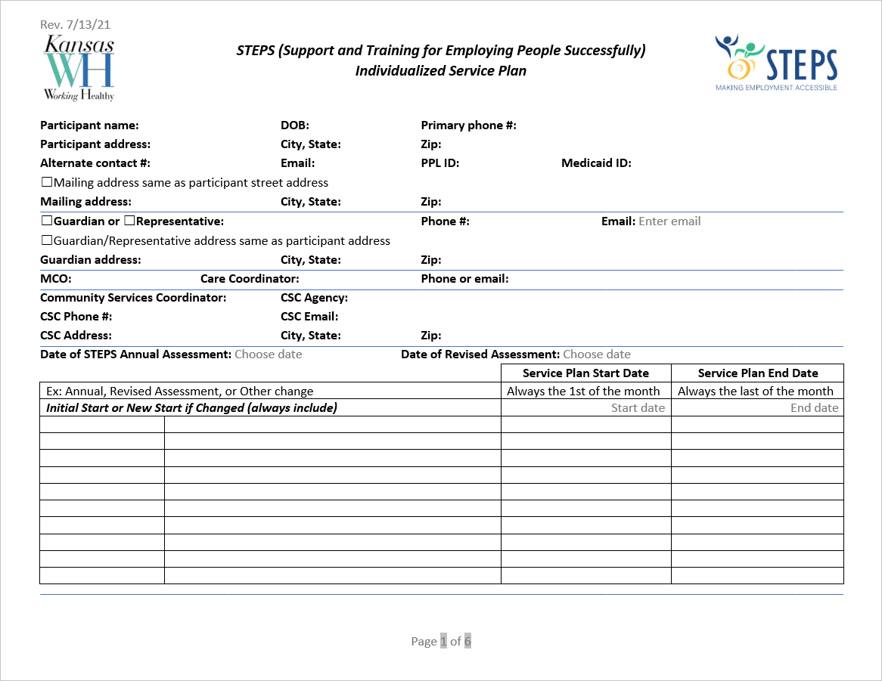

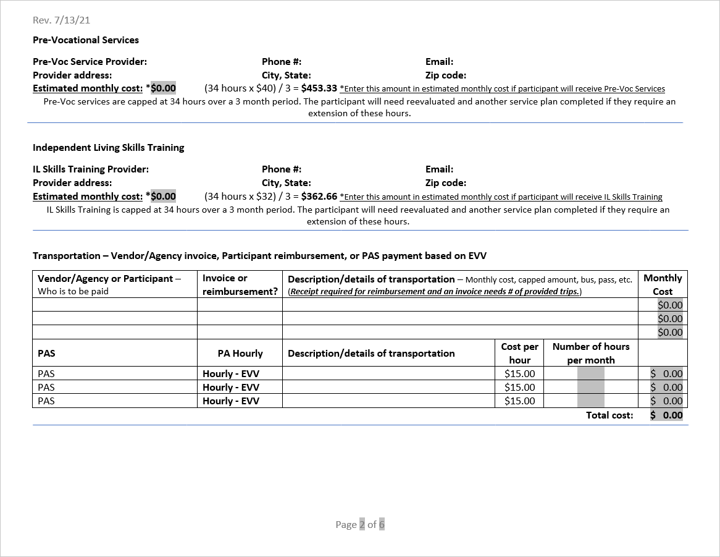

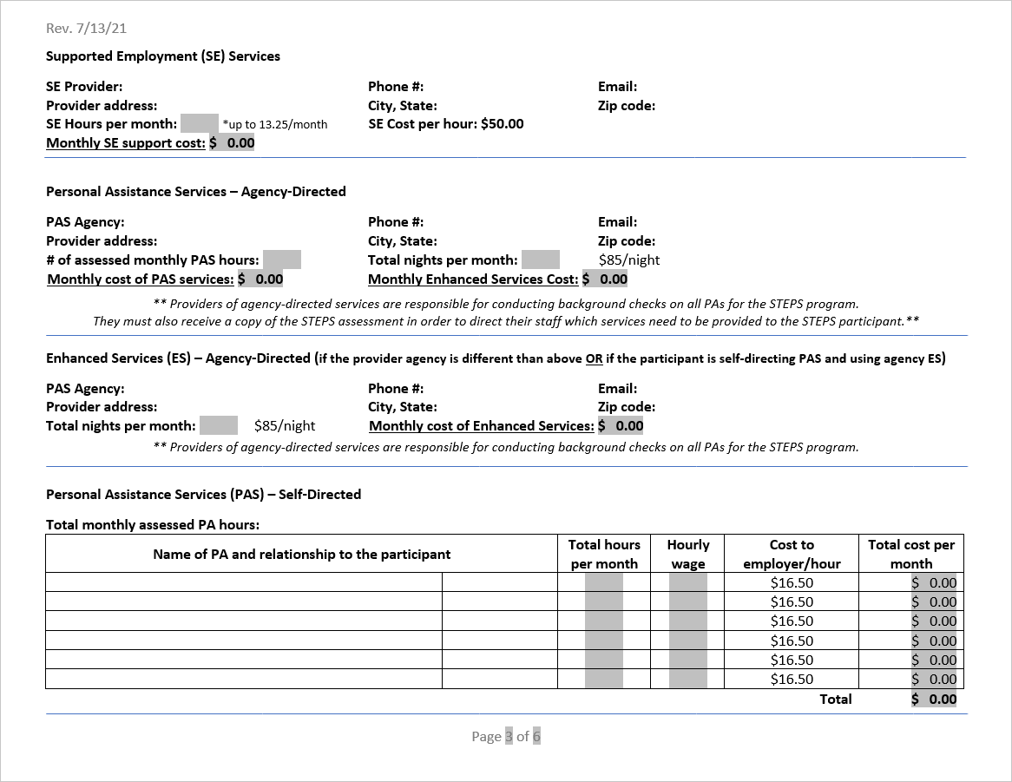

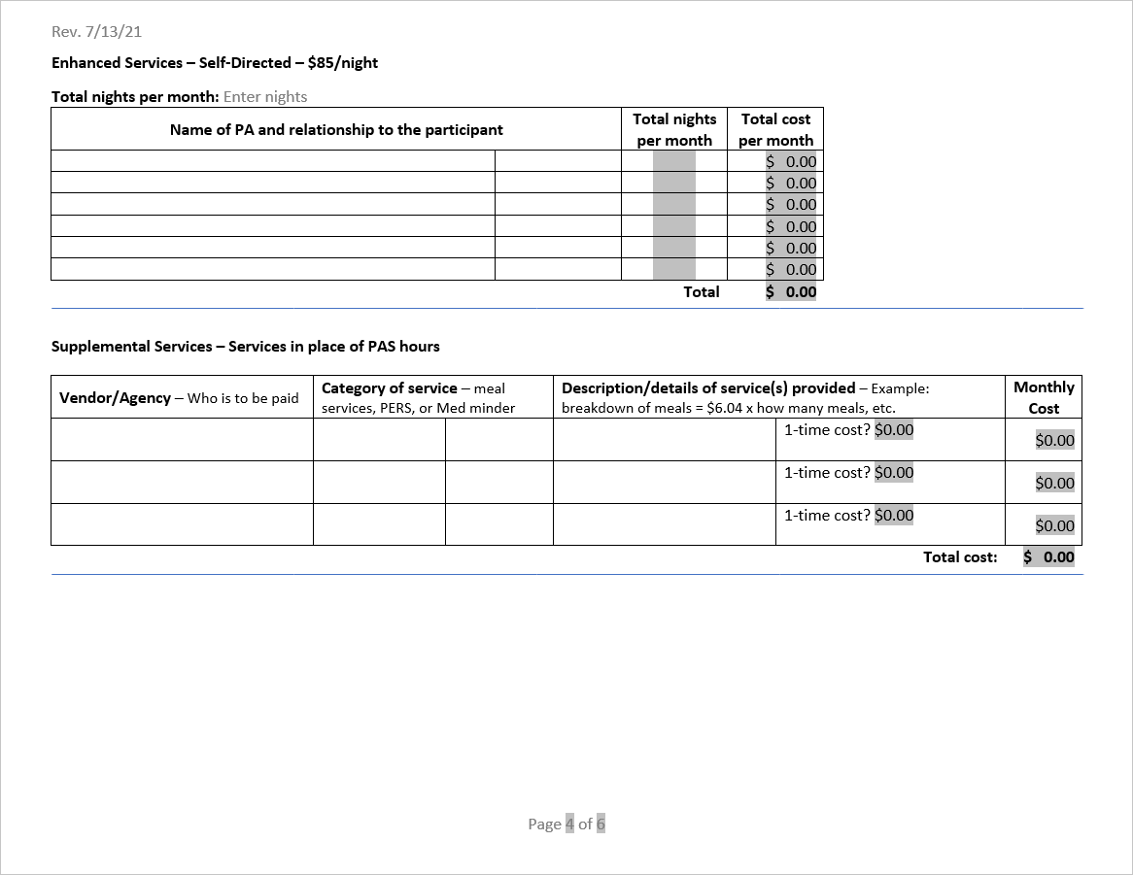

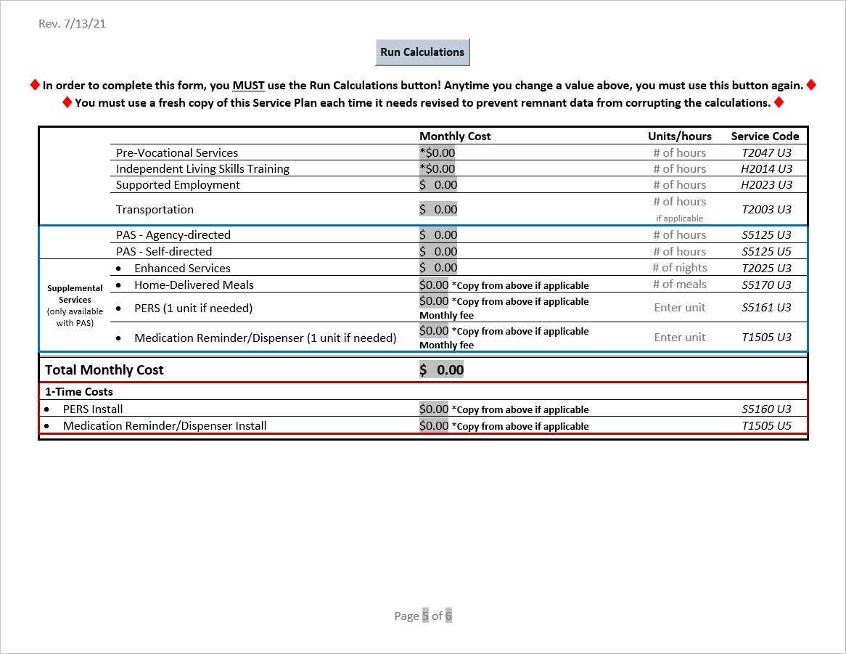

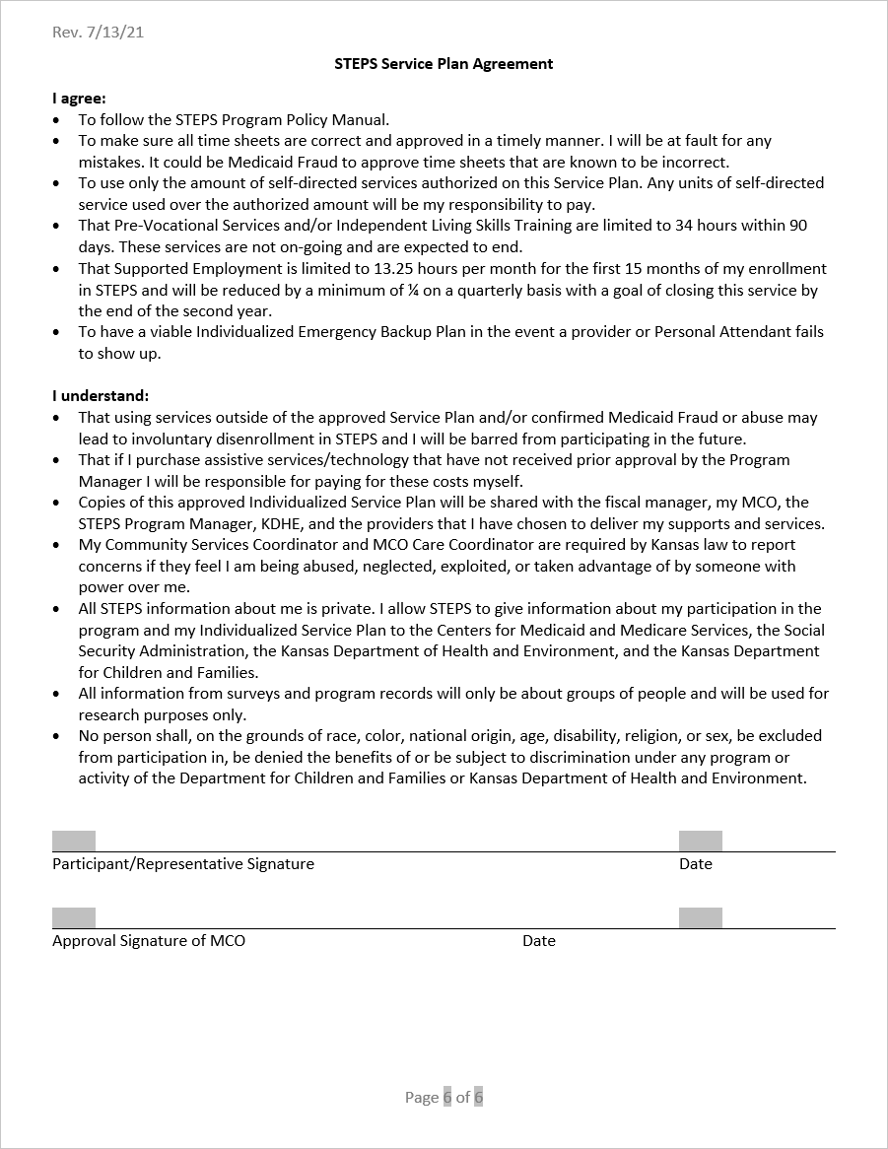

Appendix B.

Emergency Backup Plan
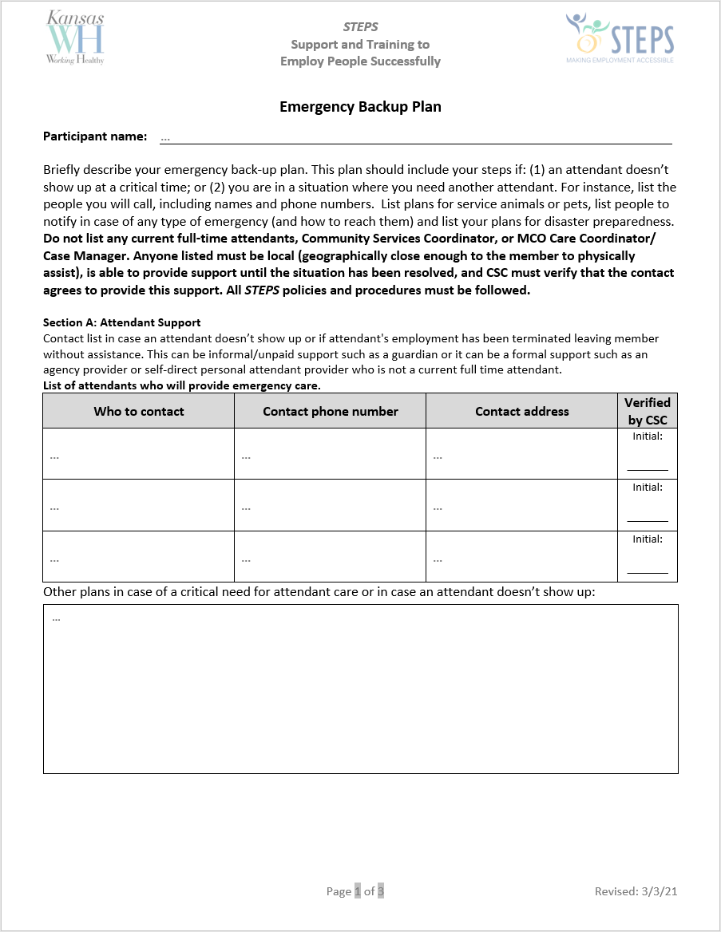
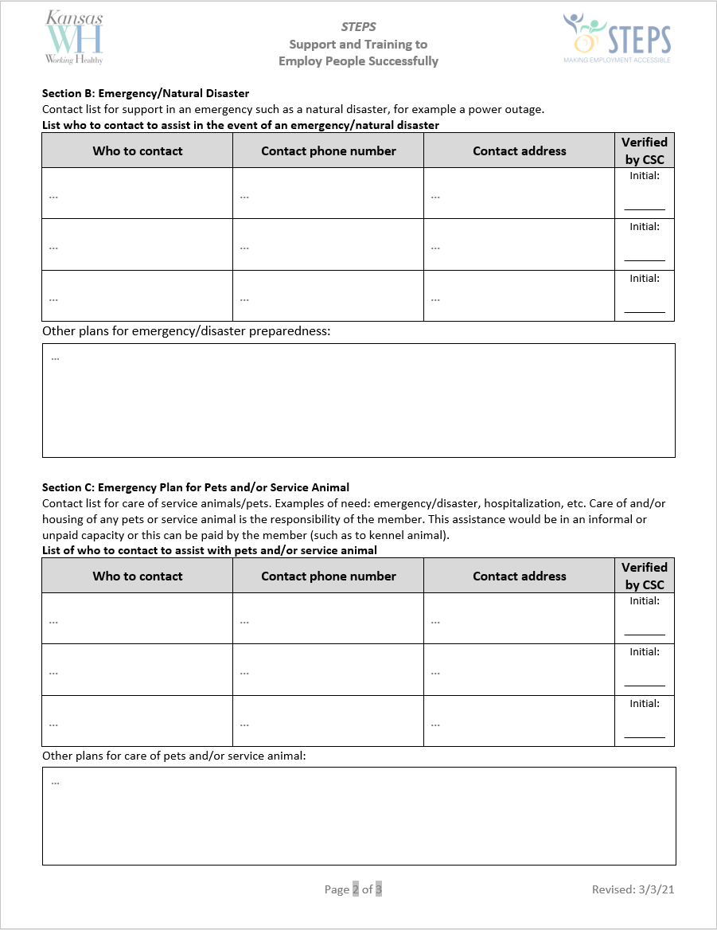
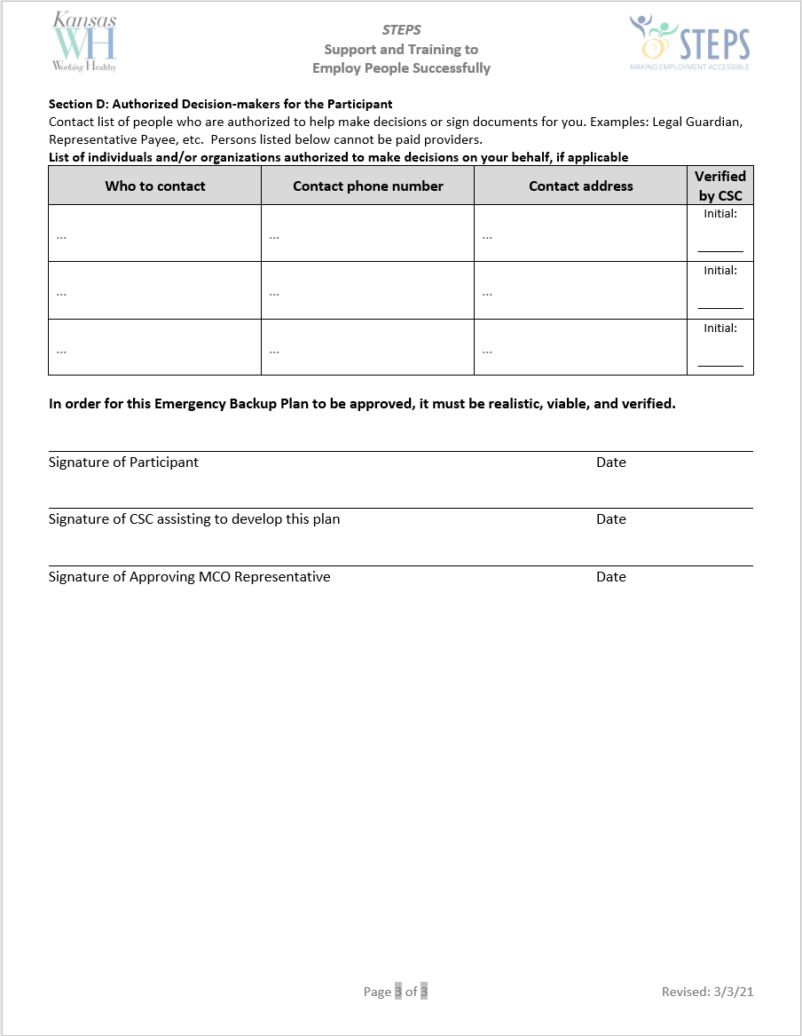

Appendix C.

Working Healthy Benefits Specialist Talking Points

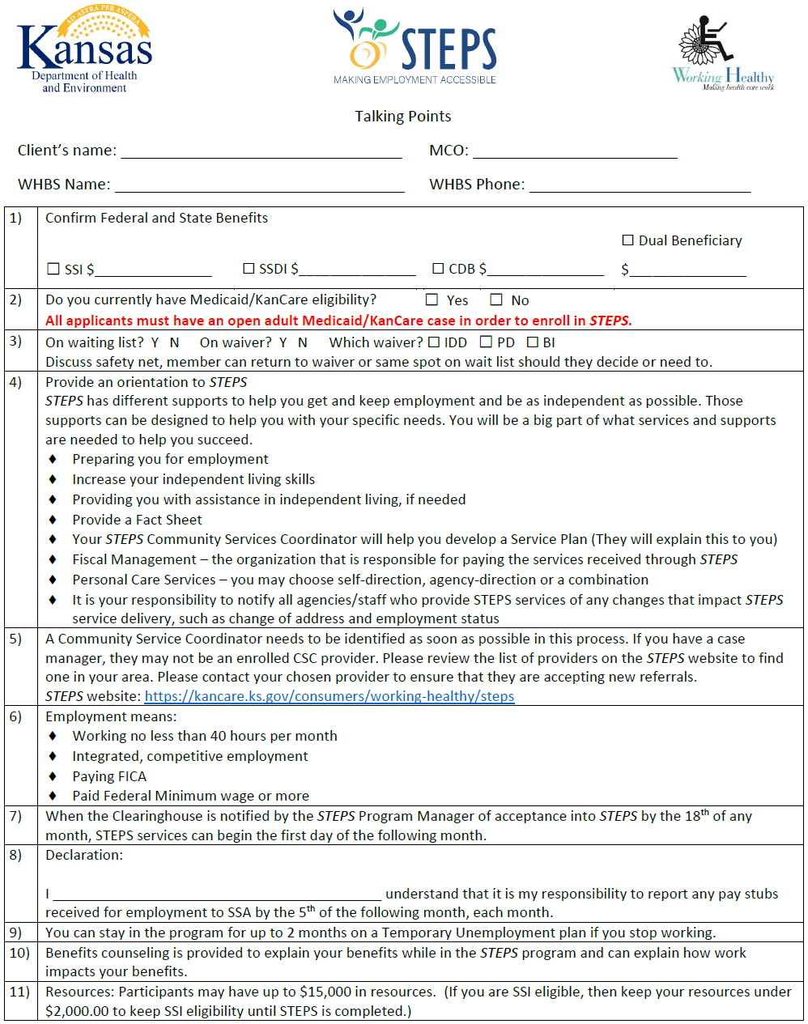

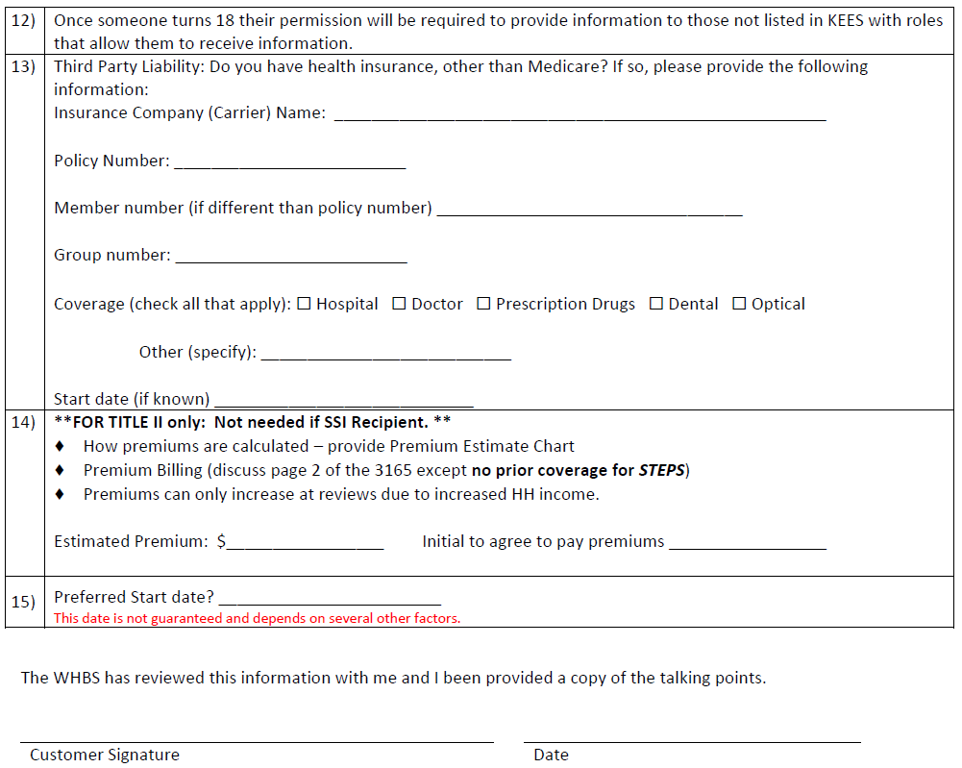

Appendix D.

Service Codes
Service |  | Service Code
Pre-Vocational |  | T2047 U3
Independent Living Skills Training |  | H2014 U3
Transportation |  | T2003 U3
Supported Employment |  | H2025 U3
Personal Assistance Services – Self-direct |  | S5125 U5
Personal Assistance Services – Agency-direct |  | S5125 U3
Only available with PAS | Enhanced Services | T2025 U3
 | Meal Delivery | S5170 U3
 | PERS – Installation | S5160 U3
 | PERS – Monthly Fee | S5161 U3
 | Medication monitoring – Installation | T1505 U3
 | Medication monitoring – Monthly Fee | T1505 U5
Assistive Services |  | Assist. Tech./Home Mod – S5165 U3  Vehicle Mod – T2039 U3
Community Service Coordination |  | T1016 U3
Financial Management Services |  | T2040 U3

Appendix E.

Acronyms
BI | Brain Injury
CDDO | Community Developmental Disability Organization
CMHC | Community Mental Health Center
CSC | Community Service Coordinator
DCF | Department of Children and Family (formerly SRS)
DHCF | Department of Health Care Finance
ES | Enhanced Services
EVV | Electronic Visit Verification
FMS | Fiscal Management Services
FPL | Federal Poverty Level
HCBS | Home and Community Based Services
I/DD | Intellectual/Developmental Disability
K.A.R. | Kansas Administrative Regulations
K.S.A. | Kansas Statutes Annotated
KDADS | Kansas Department of Aging and Disability Services
KDHE | Kansas Department of Health and Environment
MCO | Managed Care Organization (health insurance company)
CC/CM | Care Coordinator/Case Manager
PD | Physical Disability
PERS | Personal Emergency Response Systems
POA | Power of Attorney
STEPS | Support & Training for Employing People Successfully
TUP | Temporary Unemployment Plan
WH | Working Healthy

